**HTML WEBSITE**

**(Incredible India)**

A Project work report submitted in partial fulfilment of the requirement for the award the degree Post Graduate Diploma in Computer Application (PGDCA)

**Submitted By:**  
Name:  
Roll no:  
Class:  
Panjab University,Chandigarh

**INDEX**

|  |  |  |  |  |
| --- | --- | --- | --- | --- |
| **SR NO** | **TOPIC** | **PAGE NO** | **REMARKS** |  |
| 1. |  |  |  |  |
| **2** |  |  |  |  |
| **3.** |  |  |  |  |
| **4.** |  |  |  |  |
| **5.** |  |  |  |  |
| **6.** |  |  |  |  |
| **7.** |  |  |  |  |
| **8.** |  |  |  |  |
|  |  |  |  |  |

**Back End and Front End**

For the back end I have used Notepad editor for making and writing the coding for the project. Besides this we can use some more text editors available for making an html website. Some are listed below:

* Notepad
* Front Page
* Dream Weaver
* Escersoft Inc.

For the front end I have used Windows Internet Explorer browser for viewing the best output of website. And also we can use many other web browsers to view the website. Some are listed below:

* Mozilla Firefox
* Google Chrome
* Internet Explorer
* Safari
* Orca

**Hardware Requirements:**

* Windows Operating System or any other windows environment that suits web browsing
* 128 or high RAM
* 40 GB HDD
* Compatible Web browser
* Compatible text editors like front page, notepad or dream weaver

**Feasibility Study:**When the proposed system is approved, feasibility study is initiated to describe the candidate system. Four key considerations involved in feasibility analysis: economic, technical and behavioural. We can determine the performances and cost effectiveness of the proposed system and if it meets all the constraints, it is recommended in feasibility report. The key consideration involved in feasibility study as discussed below:

* Technical Feasibility: Technical feasibility centres around the hardware and software required and to what extent these will support our system along with the technical expertise required. The proposed system is technically feasible because the software used are compatible and support the program and databases design quite efficiently. Visual basic and MS Access are compatible and support the program and database designed quite efficiently.
* Behavioural Feasibility: Computers are known to facilitate change and people are usually resistant to change. In determining behavioural feasibility, we make an estimate of how strong a reaction wills the user staff to make towards the development of computerised system and try to keep the user response positive.
* Motivational Feasibility: Motivational feasibility is the measure of the extent of which the staff actually accepts the new system. The response of staff is good and favourable. They are highly motivated by working and handling records through computer instead of boring and bulk register which involves a lot of paper work and manpower.
* Social Feasibility: Survey of social feasibility is one of the most important steps in feasibility study. This is most commonly seen that the user often resist to change the working of existing system or user often resist to adopt the new software and new hardware because the user are the person who will be much affected by the new system so their agreement for the new system must be asked.
* Operational Feasibility: In the Operational feasibility we study that whether proposed system will work in right manner when implemented. The proposed systems seems to function well operational.

**Introduction of HTML**

HTML is a system of code that identify parts and characteristics of document. HTML document are plain text file. They contain no image, no sound, no video and no animation; however they can include “pointer” or links, of these types, which is how web pages end up looking as if they contain non text element. HTML is made up of tags and attributes that work together to identify document part and browser how to display them. HTML an initialize of the Hyper Text Markup Language which is predominant markup language for web pages. It provides a means to describe the structure of text based information in a document by denoting certain text as links, headings, paragraphs, lists and so on and to supplement that text with interactive forms, embedded images and other objects. HTML is written in the form of tags, surrounded by angle brackets.HTML can also describe to some degree, the appearance and semantics of a document and can include embedded scripting language code (such as Java Script) which can affect the behaviour of Web browsers and other HTML processors.  
HTML markup consist of several key components,, including elements (and their attributes), character based data types and character references and entity references.  
HTML is a language for describing web pages.  
HTML stands for Hyper Text Markup Language. HTML is not a programming language, it is a markup language.  
A markup language is a set of markup tags, HTML uses markup tags to describe web pages.

WEB PAGE:   
A web page is a resource of information that is suitable for the World Wide Web and can be accessed through a web browser. This information is usually in HTML or XHTML format and may provide navigation to other web pages via hypertext links.  
Web pages may be retrieved from a local computer or from a remote web server. The web server may restrict access only to a private network, e.g. a corporate intranet, or it may publish pages on the World Wide Web. Web pages are requested and served from web servers using Hypertext Transfer Protocol (HTTP).  
Web pages may consist of files of statics text stored within the web server’s file system or the web server may construct the HTML for each web page when it is requested by a browser .Client side scripting can make web pages more responsive to user input once in the client browser.

WEBSITE:   
A Website is a collection of related web pages, images, videos or other digital assets that are hosted on one web server, usually accessible via the Internet. A web page is a document, typically written in (X)HTML, that is almost always accessible via HTTP, protocol that transfers information from the web server to display in the user’s web browser.  
All publicly accessible websites are seen collectively as constituting the “World Wide Web”. The pages of a website can usually be accessed from a common root URL called the homepage and usually reside on the same physical server. The URLs of the pages organise them into a hierarchy, although the hyperlinks between them control how the reader perceives the overall structure an show the traffic flows between the different parts of site. Some websites require a subscription to access some or all of their content.

HYPERLINK:   
A hyperlink, usually shortened to link, is a directly follow able reference within a hypertext document. The area from which the hyperlink can be activated is called its anchor; its target is what the link points to, which may be another location within the same page or document, another page or document, or a specific location within another page or document; this depends on the type of hypertext.  
To insert a hyperlink to another place is often simply called to “link”. Hypertext (meaning “more than just” text) is a form of text typically published on websites that provides a richer functionally than simple text documents by enabling the reader to explore interesting links to other web pages linked to specific words or images within the page. Typically the link anchor will be descriptive to the target’s content.

HYPERTEXT:   
Hypertext is text, displayed on a computer, with references (hyperlinks) to other text that the reader can immediately follow, usually by a mouse click or key press sequence. Apart from running text, hypertext may contain tables, images and other presentational devices. Any of these can be hyperlinks; other means of interaction may also be present e.g. a bubble with text may appear when the mouse hovers somewhere, a video clip may be started and stopped, or a form may be filled out and submitted. The most extensive example of hypertext today is the World Wide Web.

COOKIES:  
HTTP cookies are commonly known as Web Cookies, tracking cookies or just cookies, are parcels of text sent by a server to a Web cookies and then sent back unchanged by client tie it access that server. HTTP cookies are used for authenticating, session tracking and maintaining specific information about users, such as site preferences or contents of their electronic shopping carts. The term ‘cookie’ is derived from word ‘magic cookie’, a well known concept in UNIX computing which inspired both the idea and the name of HTTP cookies.  
Some alternatives to cookies exist but each has its own advantages and drawbacks. Normal Cookies are used to remember the user who is visiting website in order to show the appropriate content. Cookies are also used by Web Servers to differentiate users and to maintain data related to user during navigation, possibly across multiple visits.  
Many websites also use cookies for personalization based on user’s preferences. Tracking cookies, however, are used to track internet users’ web browsing habits. Websites leave these tracking cookies in user’s computer and tracking software can determine where a user has been by viewing the cookies left on the computer.

HTML Element Syntax:

A HTML element starts with a start tag/option tag.  
A HTML elements ends with an end tag/closing tag.  
The element content is everything between the start and the closing tag.  
Some HTML elements have empty content and empty elements are closed in the start tag. Most HTML elements can have attributes.

Example:   
<html>  
<body>  
<h1>My name is Raj</h1>  
<p>My first paragraph</p>  
</body>  
</html>

HTML Tags

HTML markup tags are usually called HTML tags. HTML tags are keywords surrounded by angle brackets like <html>. HTML tags normally come in pairs like <b> and </b>. The first tag in a pair is the start tag; the second tag is the end tag.  
Start and end tags are also called opening tags and closing tags.

Tag - used to specify (“markup”) regions of HTML documents for each web browser to interpret.   
Element – A complete tag, having an opening <tag> and closing tag </tag>.  
Attribute – Used to modify the value of HTML element. Elements will often having multiple attributes.

HTML  
The first and last tags in a document should always be the HTML tags. These are the tags that tell a web browser where the HTML in document begins and ends.

HEAD  
The head tags contain the entire document’s header information.

TITLE  
This container is placed within the HEAD structure. This will appear at the top of the browser’s title bar and also appears in the history list.

BODY  
BODY comes after the HEAD structure. Between the BODY tags, you will find all the stuff gets displayed in the browser window. All the text, the graphics and links and so on – these things occur between the BODY tags.

HEADINGS  
The heading structures are most commonly used to set apart document or section titles.  
Format: <hN> text to appear in heading</hN> where N is number from 1 to 6 identifying the heading size.

PARAGRAPHS  
Paragraph tag is actually unpaired tag. Format: <p>enter your paragraph text here </p>

BREAKS  
To separate major sections of a web page  
<hr>: inserts a straight line.  
<br>: inserts a line break i.e. forces the text to a new line without inserting a blank line.  
These are empty tags i.e. no closing tags and no text associated with it.

STYLE TAGS  
Boldface: <b> text </b>  
Italics: <i> text </i>  
Underline: <u> text </u>

LISTS  
Unordered lists (items preceded with a “bullet”) : <ul>text</ul>  
Ordered lists (a sequentially numbered list) : <li>text</li>

ADDING COLORS  
Background Colour : <body bgcolor= “#FFFFFF”> or <body bgcolor= “green”>  
Text Colour : <body text= “blue”> or <body bgcolor= “red” text= “yellow”>

GRAPHICS  
Inline Graphics : <img src= “filename.jpg”>   
Alternative Text : <img alt= “our logo” src= “logo.jpg”>  
Height and Width Attributes : <img src= “sweethome.jpg” width=600 height=200 border= “3”>

LINKING THE DOCUMENTS  
HREF : <a href= “http://servername.com/myfolder/index.html”>See my welcome message </a> where ‘a’ is an anchor tag

TABLES  
HTML tables are grids made up of rows and columns.  
Format: <table>  
<tr><td>one kind</td></tr>  
<tr><td>second kind</td></tr>  
<tr><td>third kind</td></tr>  
<tr><td>fourth kind</td></tr>  
</table>

FORMS  
Forms are used to allow communication between your viewers and website to gather information and to offer different means of navigation.  
FORMAT : <form method= “post” action= “/cgi-bin/program1”>   
<input type= “text” name= “text1” size= “30”>  
<input type= “radio” name= “fav_os” values= “dos”>DOS </form>

**Incredible India**

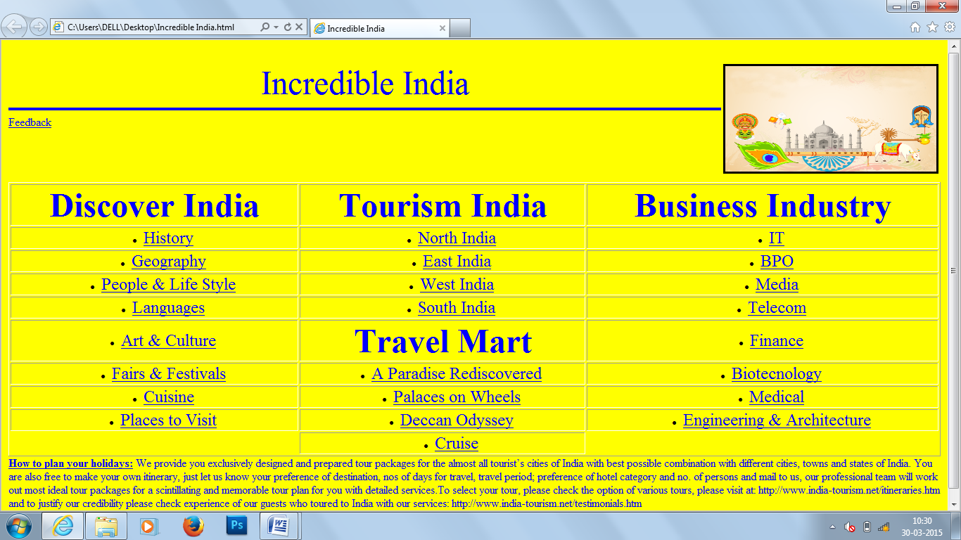

<html>

<head>

<title>Incredible India</title>

</head ><br>

<body bgcolor="yellow">

<image align="right" img src="E:\discvrr.png" width="300" height="150" border="3">

<center><font size="10" color="blue">Incredible India</font></center>

<hr align="centre" width="100%" size="4" color="blue">

<left><u><font size="3" color="blue">Feedback</font></u></left>

<br><br><br><br><br>

<table border="1" style="width:100%">

<tr>

<td><center><b><font size="10" color="blue">Discover India</td>

<td><center><b><font size="10" color="blue">Tourism India</td>

<td><center><b><font size="10" color="blue">Business Industry</td>

</tr>

<tr>

<td><center><ul><li><a href="E:\HISTORY.html" target="new"><font size="5" color="blue">History</td>

<td><center><ul><li><a href="E:\north india.html" target="new"><font size="5" color="blue">North India</td>

<td><center><ul><li><a href="E:\IT.html" target="new"><font size="5" color="blue">IT</td>

</tr>

<tr>

<td><center><ul><li><a href="E:\GEOGRAPHY.html" target="new"><font size="5" color="blue">Geography</td>

<td><center><ul><li><a href="E:\east india.html" target="new"><font size="5" color="blue">East India</td>

<td><center><ul><li><a href="E:\BPO.html" target="new"><font size="5" color="blue">BPO</td>

</tr>

<tr>

<td><center><ul><li><a href="E:\PEOPLE & LIFE STYLE.html" target="new"><font size="5" color="blue">People & Life Style</td>

<td><center><ul><li><a href="E:\west india.html" target="new"><font size="5" color="blue">West India</td>

<td><center><ul><li><a href="E:\Media.html" target="new"><font size="5" color="blue">Media</td>

</tr>

<tr>

<td><center><ul><li><a href="E:\LANGUAGES.html" target="new"><font size="5" color="blue">Languages</td>

<td><center><ul><li><a href="E:\south india.html" target="new"><font size="5" color="blue">South India</td>

<td><center><ul><li><a href="E:\Telecom.html" target="new"><font size="5" color="blue">Telecom</td>

</tr>

<tr>

<td><center><ul><li><a href="E:\ART & CULTURE.html" target="new"><font size="5" color="blue">Art & Culture</td>

<td><center><b><font size="10" color="blue">Travel Mart</td>

<td><center><ul><li><a href="E:\Finance.html" target="new"><font size="5" color="blue">Finance</td>

</tr>

<tr>

<td><center><ul><li><a href="E:\FAIRS & FESTIVALS.html" target="new"><font size="5" color="blue">Fairs & Festivals</td>

<td><center><ul><li><a href="E:\paradise.html" target="new"><font size="5" color="blue">A Paradise Rediscovered</td>

<td><center><ul><li><a href="E:\Biotechnology.html" target="new"><font size="5" color="blue">Biotecnology</td>

</tr>

<tr>

<td><center><ul><li><a href="E:\CUISINE.html" target="new"><font size="5" color="blue">Cuisine</td>

<td><center><ul><li><a href="E:\palaces.html" target="new"><font size="5" color="blue">Palaces on Wheels</td>

<td><center><ul><li><a href="E:\Medical.html" target="new"><font size="5" color="blue">Medical</td>

</tr>

<tr>

<td><center><ul><li><a href="E:\PLACES TO VISIT.html" target="new"><font size="5" color="blue">Places to Visit</td>

<td><center><ul><li><a href="E:\deccan.html" target="new"><font size="5" color="blue">Deccan Odyssey</td>

<td><center><ul><li><a href="E:\Engineering & Architecture.html" target="new"><font size="5" color="blue">Engineering & Architecture</td>

<tr>

<td></td>

<td><center><ul><li><a href="E:\cruise.html" target="new"><font size="5" color="blue">Cruise</td>

<td></td>

</tr>

</table>

<font size="3" color="blue">

<b><u>How to plan your holidays:</u></b>

We provide you exclusively designed and prepared tour packages for the almost all tourist’s cities of India with best possible combination with different cities, towns and states of India. You are also free to make your own itinerary, just let us know your preference of destination, nos of days for travel, travel period; preference of hotel category and no. of persons and mail to us, our professional team will work out most ideal tour packages for a scintillating and memorable tour plan for you with detailed services.To select your tour, please check the option of various tours, please visit at: http://www.india-tourism.net/itineraries.htm and to justify our credibility please check experience of our guests who toured to India with our services: http://www.india-tourism.net/testimonials.htm

</font>

</body>

</html>

Feedback

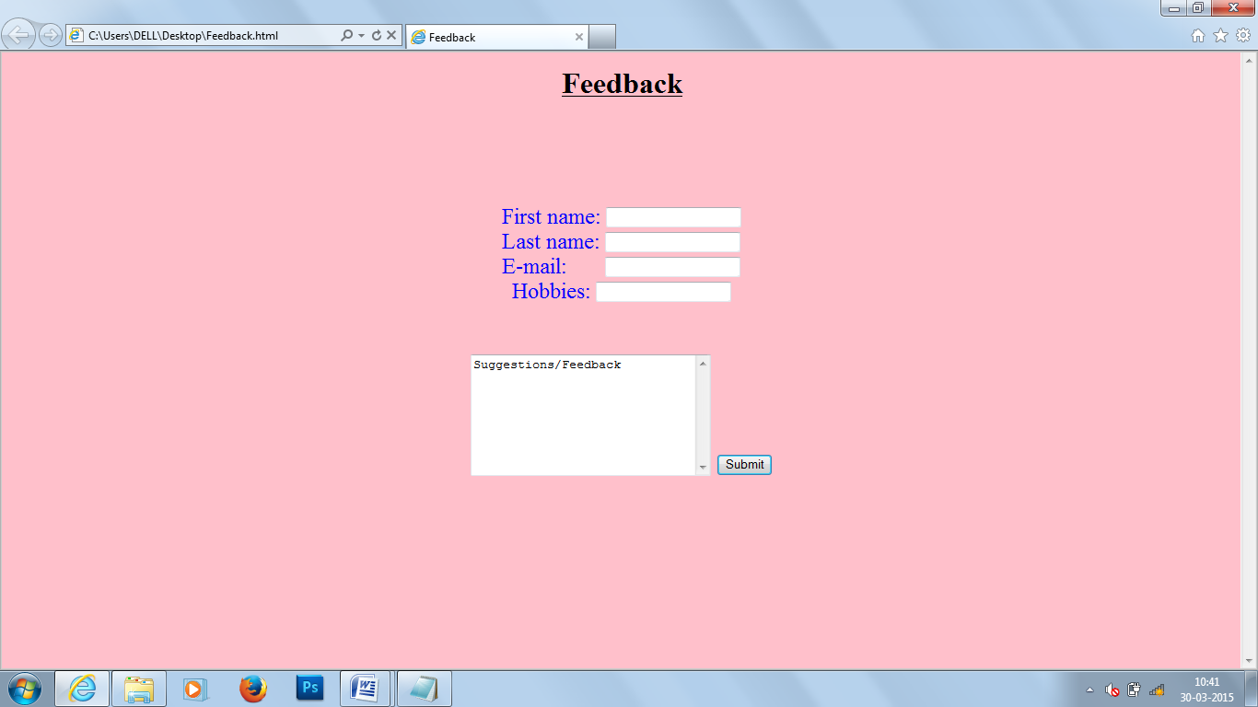

<html>

<head>

<title>Feedback</title>

<head>

<body bgcolor="pink">

<b><marquee><u><h1>Feedback</h1><u></marquee></b><br><br><br><br><br><br>

<center>

<font size=5 color="blue">

<form>

First name: <input type="text" name="firstname"><br>

Last name: <input type="text" name="lastname"><br>

E-mail:&nbsp;&nbsp;&nbsp;&nbsp;&nbsp;&nbsp; <input type="text" name="emailid"><br>

Hobbies: <input type="text" name="Hobbies"><br><br><br>

<textarea name="message" rows="8" cols="30">

Suggestions/Feedback</textarea >

<input type="submit" value="Submit">

</form>

</body>

</html>

**DISCOVER India**

History of India

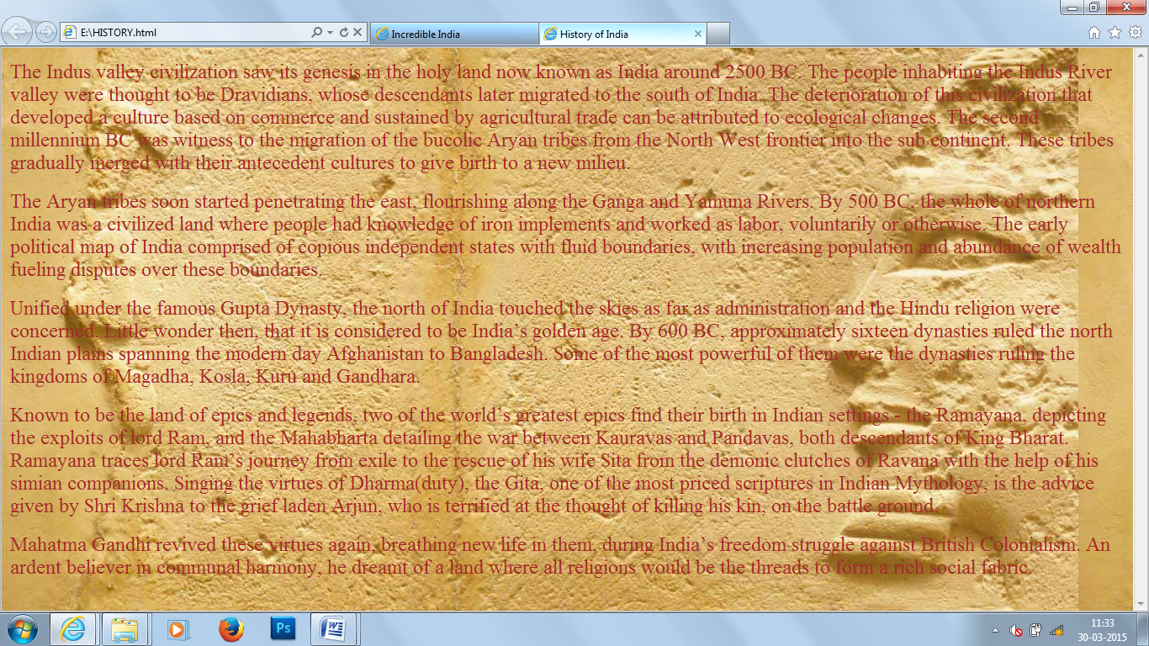

<html>

<head>

<title>

History of India

</title>

</head>

<body background="E:\hstry1.jpg" text="black">

<font size=5><p>

The Indus valley civilization saw its genesis in the holy land now known as India around 2500 BC. The people inhabiting the Indus

River valley were thought to be Dravidians, whose descendants later migrated to the south of India. The deterioration of this

civilization that developed a culture based on commerce and sustained by agricultural trade can be attributed to ecological changes.

The second millennium BC was witness to the migration of the bucolic Aryan tribes from the North West frontier into the sub

continent. These tribes gradually merged with their antecedent cultures to give birth to a new milieu.</p><p>

The Aryan tribes soon started penetrating the east, flourishing along the Ganga and Yamuna Rivers. By 500 BC, the whole of

northern India was a civilized land where people had knowledge of iron implements and worked as labor, voluntarily or otherwise.

The early political map of India comprised of copious independent states with fluid boundaries, with increasing population and

abundance of wealth fueling disputes over these boundaries.</p><p>

Unified under the famous Gupta Dynasty, the north of India touched the skies as far as administration and the Hindu religion were

concerned. Little wonder then, that it is considered to be India’s golden age. By 600 BC, approximately sixteen dynasties ruled the

north Indian plains spanning the modern day Afghanistan to Bangladesh. Some of the most powerful of them were the dynasties

ruling the kingdoms of Magadha, Kosla, Kuru and Gandhara.</p><p>

Known to be the land of epics and legends, two of the world’s greatest epics find their birth in Indian settings - the Ramayana,

depicting the exploits of lord Ram, and the Mahabharta detailing the war between Kauravas and Pandavas, both descendants of King

Bharat. Ramayana traces lord Ram’s journey from exile to the rescue of his wife Sita from the demonic clutches of Ravana with the

help of his simian companions. Singing the virtues of Dharma(duty), the Gita, one of the most priced scriptures in Indian Mythology,

is the advice given by Shri Krishna to the grief laden Arjun, who is terrified at the thought of killing his kin, on the battle

ground.</p><p>Mahatma Gandhi revived these virtues again, breathing new life in them, during India’s freedom struggle against

British Colonialism. An ardent believer in communal harmony, he dreamt of a land where all religions would be the threads to form a

rich social fabric.</p>

</font>

</head>

</html>

Geography of India

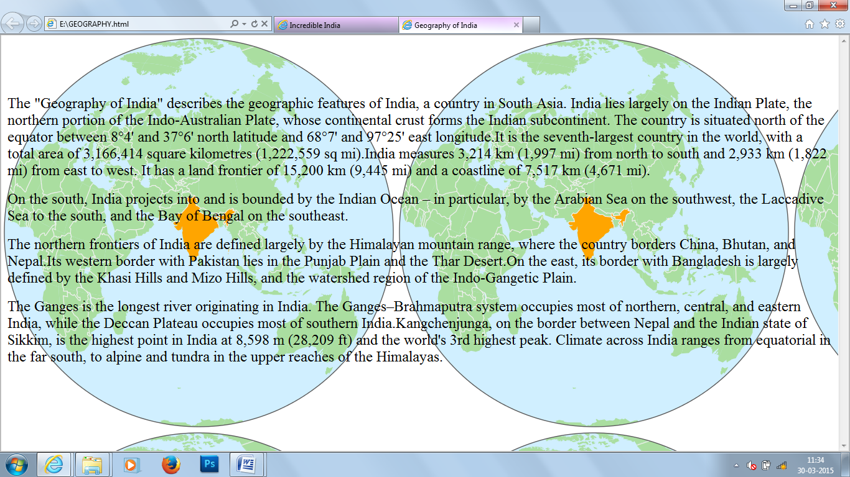

<html>

<head>

<title>

Geography of India

</title>

</head>

<body background="E:\geo1.png" text="black">

<font size=5><br><br><br><p>

The "Geography of India" describes the geographic features of India, a country in South Asia. India lies largely on the Indian Plate,

the northern portion of the Indo-Australian Plate, whose continental crust forms the Indian subcontinent. The country is situated

north of the equator between 8°4' and 37°6' north latitude and 68°7' and 97°25' east longitude.It is the seventh-largest country in the

world, with a total area of 3,166,414 square kilometres (1,222,559 sq mi).India measures 3,214 km (1,997 mi) from north to south and

2,933 km (1,822 mi) from east to west. It has a land frontier of 15,200 km (9,445 mi) and a coastline of 7,517 km (4,671 mi).</p><p>

On the south, India projects into and is bounded by the Indian Ocean – in particular, by the Arabian Sea on the southwest, the

Laccadive Sea to the south, and the Bay of Bengal on the southeast.</p><p>The northern frontiers of India are defined largely by the

Himalayan mountain range, where the country borders China, Bhutan, and Nepal.Its western border with Pakistan lies in the Punjab

Plain and the Thar Desert.On the east, its border with Bangladesh is largely defined by the Khasi Hills and Mizo Hills, and the

watershed region of the Indo-Gangetic Plain.</p><p>The Ganges is the longest river originating in India. The Ganges–Brahmaputra

system occupies most of northern, central, and eastern India, while the Deccan Plateau occupies most of southern

India.Kangchenjunga, on the border between Nepal and the Indian state of Sikkim, is the highest point in India at 8,598 m (28,209 ft)

and the world's 3rd highest peak. Climate across India ranges from equatorial in the far south, to alpine and tundra in the upper

reaches of the Himalayas.</p>

</font>

</head>

</html>

People & Life Style

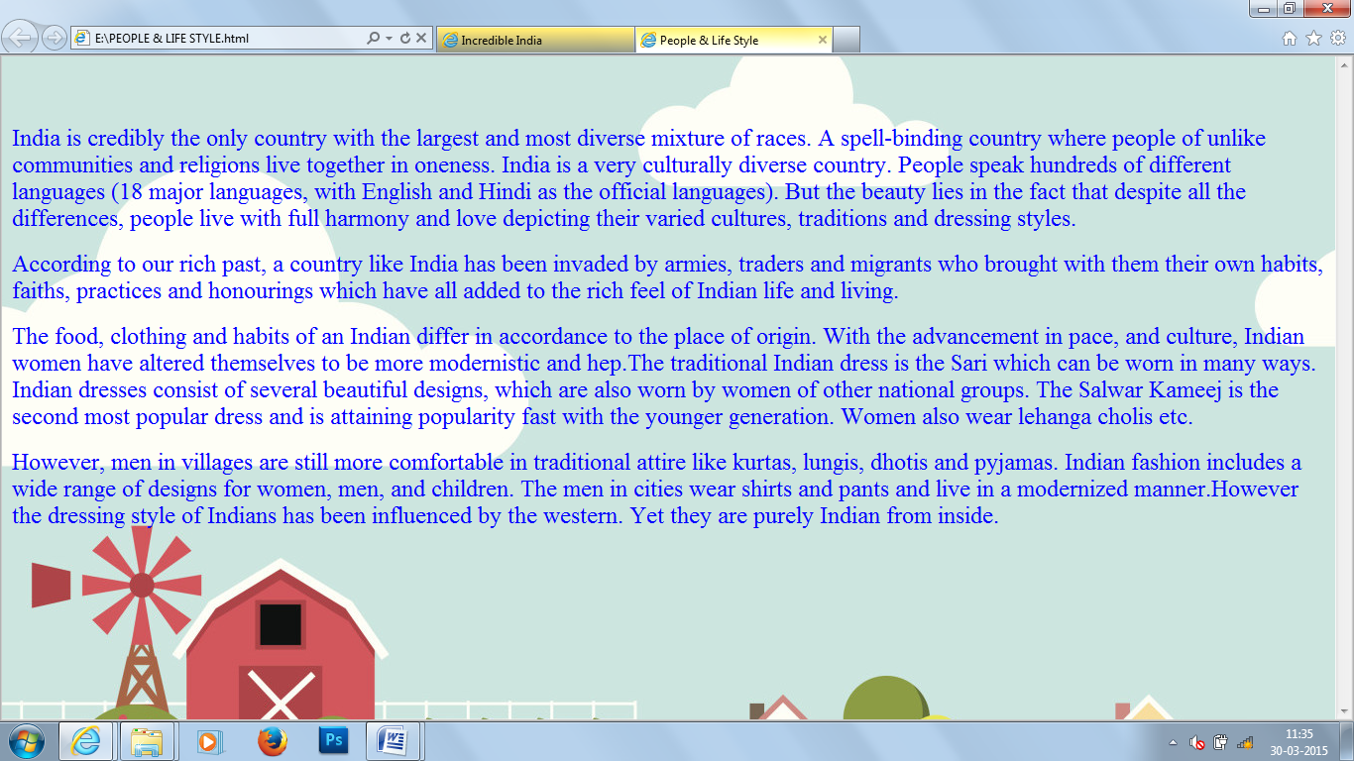

<html>

<head>

<title>

People & Life Style

</title>

</head>

<body background="E:\life.jpg" text="blue">

<font size=5><br><br><p>

India is credibly the only country with the largest and most diverse mixture of races. A spell-binding country where people of unlike

communities and religions live together in oneness. India is a very culturally diverse country. People speak hundreds of different

languages (18 major languages, with English and Hindi as the official languages). But the beauty lies in the fact that despite all the

differences, people live with full harmony and love depicting their varied cultures, traditions and dressing styles.</p><p>According

to our rich past, a country like India has been invaded by armies, traders and migrants who brought with them their own habits,

faiths, practices and honourings which have all added to the rich feel of Indian life and living.</p><p>The food, clothing and habits of

an Indian differ in accordance to the place of origin. With the advancement in pace, and culture, Indian women have altered

themselves to be more modernistic and hep.The traditional Indian dress is the Sari which can be worn in many ways. Indian dresses

consist of several beautiful designs, which are also worn by women of other national groups. The Salwar Kameej is the second most

popular dress and is attaining popularity fast with the younger generation. Women also wear lehanga cholis etc.</p><p>However,

men in villages are still more comfortable in traditional attire like kurtas, lungis, dhotis and pyjamas. Indian fashion includes a wide

range of designs for women, men, and children. The men in cities wear shirts and pants and live in a modernized manner.However

the dressing style of Indians has been influenced by the western. Yet they are purely Indian from inside.</p>

</font>

</head>

</html>

Languages

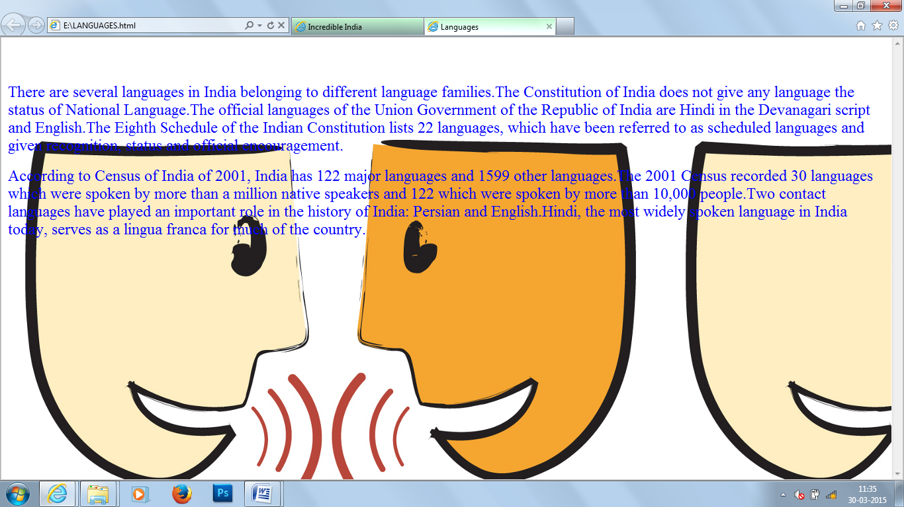

<html>

<head>

<title>

Languages

</title>

</head>

<body background="E:\lang.jpg" text="blue">

<font size=5><br><br><p>

There are several languages in India belonging to different language families.The Constitution of India does not give any language

the status of National Language.The official languages of the Union Government of the Republic of India are Hindi in the Devanagari

script and English.The Eighth Schedule of the Indian Constitution lists 22 languages, which have been referred to as scheduled

languages and given recognition, status and official encouragement.</p><p>According to Census of India of 2001, India has 122

major languages and 1599 other languages.The 2001 Census recorded 30 languages which were spoken by more than a million

native speakers and 122 which were spoken by more than 10,000 people.Two contact languages have played an important role in the

history of India: Persian and English.Hindi, the most widely spoken language in India today, serves as a lingua franca for much of the

country.

</p>

</font>

</head>

</html>

Art & Culture

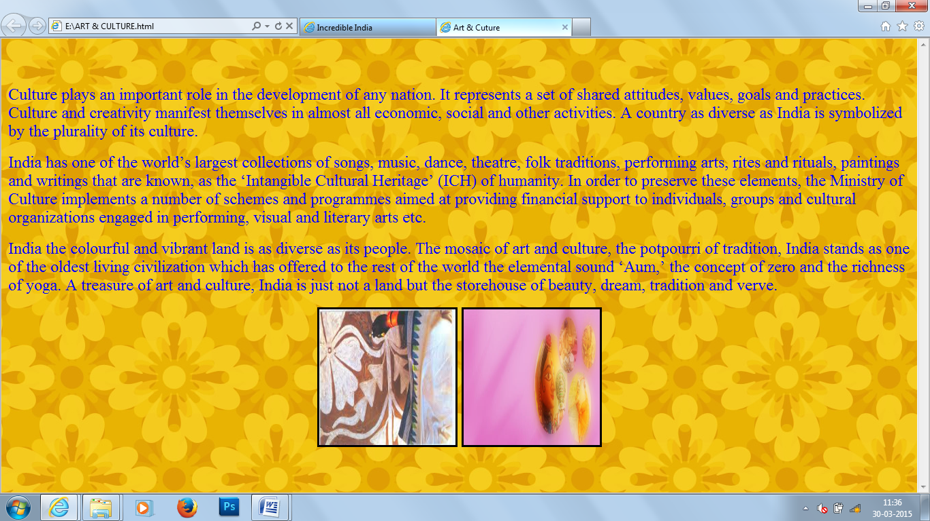

<html>

<head>

<title>

Art & Culture

</title>

</head>

<body background="E:\art2.jpg" text="blue">

<font size=5><br><br><p>

Culture plays an important role in the development of any nation. It represents a set of shared attitudes, values, goals and practices.

Culture and creativity manifest themselves in almost all economic, social and other activities. A country as diverse as India is

symbolized by the plurality of its culture.</p><p>India has one of the world’s largest collections of songs, music, dance, theatre, folk

traditions, performing arts, rites and rituals, paintings and writings that are known, as the ‘Intangible Cultural Heritage’ (ICH) of

humanity. In order to preserve these elements, the Ministry of Culture implements a number of schemes and programmes aimed at

providing financial support to individuals, groups and cultural organizations engaged in performing, visual and literary arts

etc.</p><p>India the colourful and vibrant land is as diverse as its people. The mosaic of art and culture, the potpourri of tradition,

India stands as one of the oldest living civilization which has offered to the rest of the world the elemental sound ‘Aum,’ the concept

of zero and the richness of yoga. A treasure of art and culture, India is just not a land but the storehouse of beauty, dream, tradition

and verve.

</p>  
<center><img src="E:\art1.jpg" width="200" height="200" border="3">

<img src="E:\art2.jpg" width="200" height="200" border="3">

</font>

</head>

</html>

Fair & Festivals

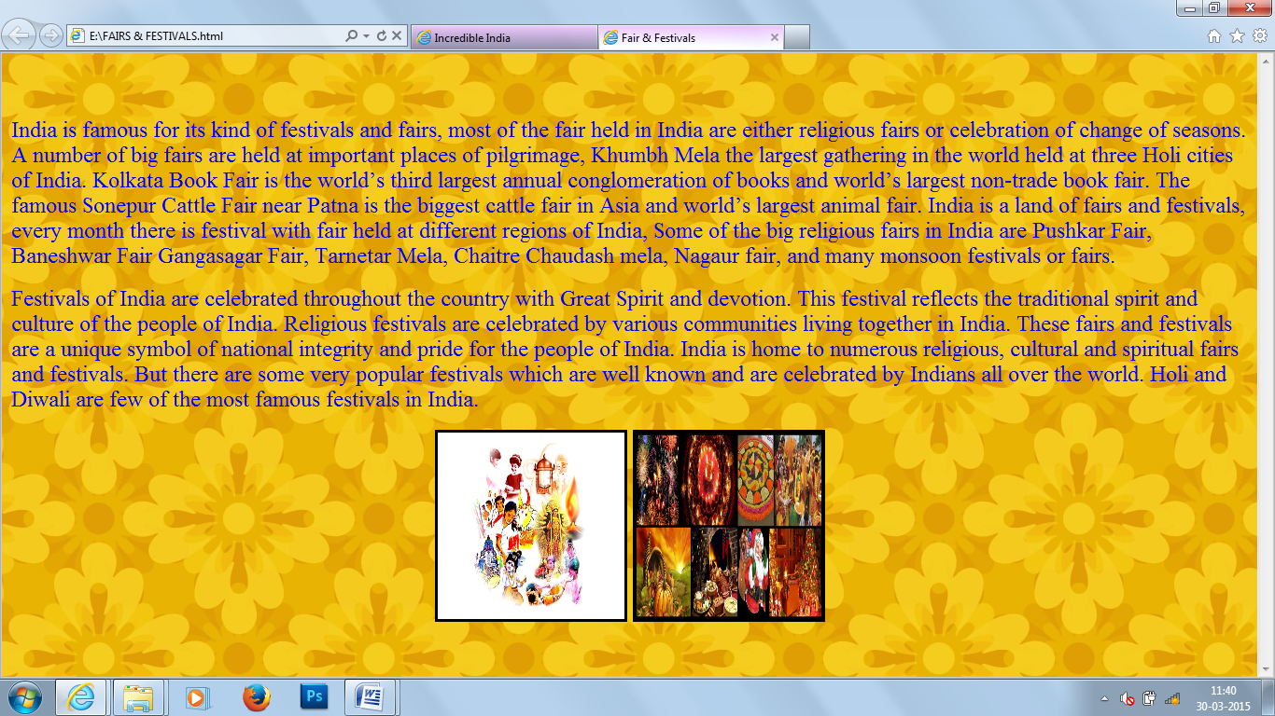

<html>

<head>

<title>

Fair & Festivals

</title>

</head>

<body background="E:\b5.jpg" text="blue">

<font size=5><br><br><p>

India is famous for its kind of festivals and fairs, most of the fair held in India are either religious fairs or celebration of change of seasons. A number of big fairs are held at important places of pilgrimage, Khumbh Mela the largest gathering in the world held at three Holi cities of India. Kolkata Book Fair is the world’s third largest annual conglomeration of books and world’s largest non-trade book fair. The famous Sonepur Cattle Fair near Patna is the biggest cattle fair in Asia and world’s largest animal fair. India is a land of fairs and festivals, every month there is festival with fair held at different regions of India, Some of the big religious fairs in India are Pushkar Fair, Baneshwar Fair Gangasagar Fair, Tarnetar Mela, Chaitre Chaudash mela, Nagaur fair, and many monsoon festivals or fairs.</p><p>Festivals of India are celebrated throughout the country with Great Spirit and devotion. This festival reflects the traditional spirit and culture of the people of India. Religious festivals are celebrated by various communities living together in India. These fairs and festivals are a unique symbol of national integrity and pride for the people of India. India is home to numerous religious, cultural and spiritual fairs and festivals. But there are some very popular festivals which are well known and are celebrated by Indians all over the world. Holi and Diwali are few of the most famous festivals in India.

</p>

<center><img src="E:\fest.jpg" width="200" height="200" border="3">

<img src="E:\fest1.jpg" width="200" height="200" border="3">

</font>

</head>

</html>

Cuisine

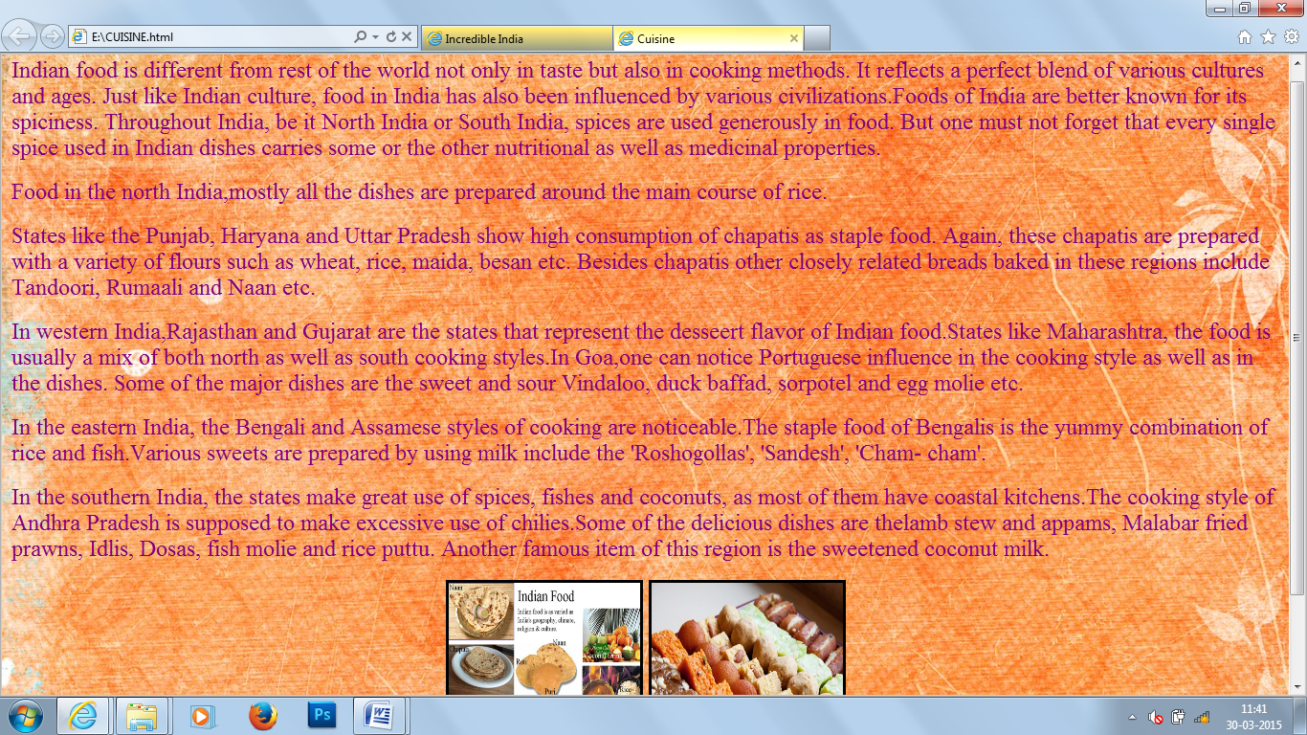

<html>

<head>

<title>

Cuisine

</title>

</head>

<body background="E:\b2.jpg" text="green">

<font size=5><p>

Indian food is different from rest of the world not only in taste but also in cooking methods. It reflects a perfect blend of various

cultures and ages. Just like Indian culture, food in India has also been influenced by various civilizations.Foods of India are better

known for its spiciness. Throughout India, be it North India or South India, spices are used generously in food. But one must not

forget that every single spice used in Indian dishes carries some or the other nutritional as well as medicinal properties.</p><p>Food

in the north India,mostly all the dishes are prepared around the main course of rice.</p><p>States like the Punjab, Haryana and Uttar

Pradesh show high consumption of chapatis as staple food. Again, these chapatis are prepared with a variety of flours such as

wheat, rice, maida, besan etc. Besides chapatis other closely related breads baked in these regions include Tandoori, Rumaali and

Naan etc.</p><p>In western India,Rajasthan and Gujarat are the states that represent the desseert flavor of Indian food.States like

Maharashtra, the food is usually a mix of both north as well as south cooking styles.In Goa,one can notice Portuguese influence in

the cooking style as well as in the dishes. Some of the major dishes are the sweet and sour Vindaloo, duck baffad, sorpotel and egg

molie etc.</p><p>In the eastern India, the Bengali and Assamese styles of cooking are noticeable.The staple food of Bengalis is the

yummy combination of rice and fish.Various sweets are prepared by using milk include the 'Roshogollas', 'Sandesh', 'Cham-

cham'.</p><p>In the southern India, the states make great use of spices, fishes and coconuts, as most of them have coastal

kitchens.The cooking style of Andhra Pradesh is supposed to make excessive use of chilies.Some of the delicious dishes are thelamb

stew and appams, Malabar fried prawns, Idlis, Dosas, fish molie and rice puttu. Another famous item of this region is the sweetened

coconut milk.

</p>

<center><img src="E:\cus.jpg" width="200" height="200" border="3">

<img src="E:\cus1.jpg" width="200" height="200" border="3">

</font>

</head>

</html>

Places to Visit

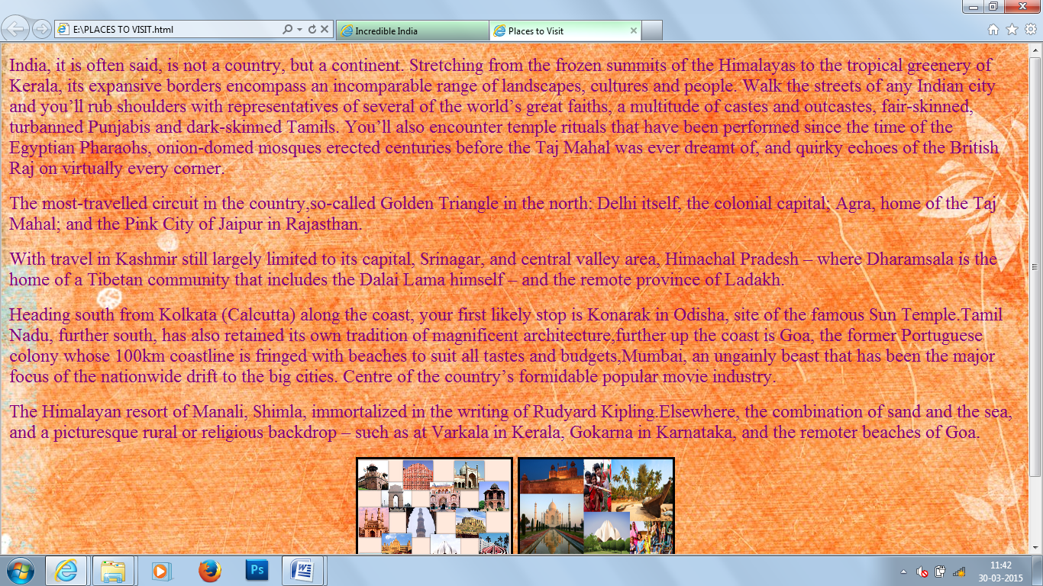

<html>

<head>

<title>

Places to Visit

</title>

</head>

<body background="E:\b3.jpg" text="purple">

<font size=5><p>

India, it is often said, is not a country, but a continent. Stretching from the frozen summits of the Himalayas to the tropical greenery of Kerala, its expansive borders encompass an incomparable range of landscapes, cultures and people. Walk the streets of any Indian city and you’ll rub shoulders with representatives of several of the world’s great faiths, a multitude of castes and outcastes, fair-skinned, turbanned Punjabis and dark-skinned Tamils. You’ll also encounter temple rituals that have been performed since the time of the Egyptian Pharaohs, onion-domed mosques erected centuries before the Taj Mahal was ever dreamt of, and quirky echoes of the British Raj on virtually every corner.<p>The most-travelled circuit in the country,so-called Golden Triangle in the north: Delhi itself, the colonial capital; Agra, home of the Taj Mahal; and the Pink City of Jaipur in Rajasthan.</p><p>With travel in Kashmir still largely limited to its capital, Srinagar, and central valley area, Himachal Pradesh – where Dharamsala is the home of a Tibetan community that includes the Dalai Lama himself – and the remote province of Ladakh.</p><p>Heading south from Kolkata (Calcutta) along the coast, your first likely stop is Konarak in Odisha, site of the famous Sun Temple.Tamil Nadu, further south, has also retained its own tradition of magnificent architecture,further up the coast is Goa, the former Portuguese colony whose 100km coastline is fringed with beaches to suit all tastes and budgets,Mumbai, an ungainly beast that has been the major focus of the nationwide drift to the big cities. Centre of the country’s formidable popular movie industry.</p><p> The Himalayan resort of Manali, Shimla, immortalized in the writing of Rudyard Kipling.Elsewhere, the combination of sand and the sea, and a picturesque rural or religious backdrop – such as at Varkala in Kerala, Gokarna in Karnataka, and the remoter beaches of Goa.

</p>

<center><img src="E:\tour1.jpg" width="200" height="200" border="3">

<img src="E:\tour2.jpg" width="200" height="200" border="3">

</font>

</head>

</html>

**Tourism India**

North India

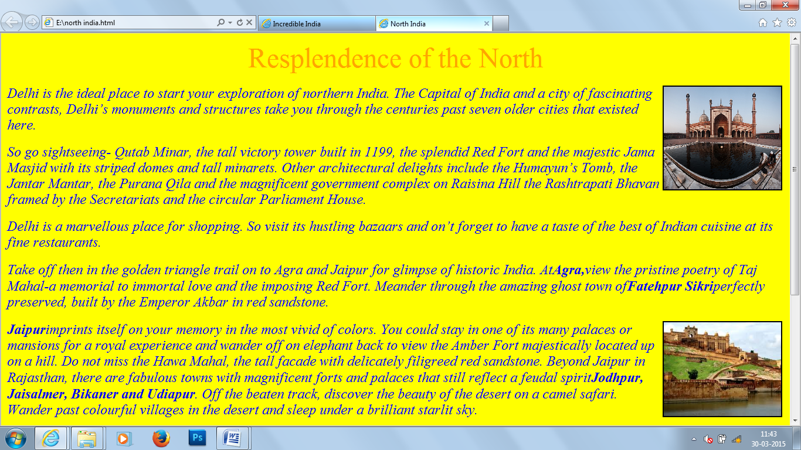

<html>

<head>

<title>

North India

</title>

</head>

<body bgcolor="yellow" text="blue">

<center>

<font color="orange" size="8">Resplendence of the North</font>

</center>

<font size=5>

<p>

<i>

<img src="E:\jama.jpg" width= "200" height= "175" align= "right" border="2">

Delhi is the ideal place to start your exploration of northern India. The Capital of India and a city of fascinating contrasts, Delhi’s

monuments and structures take you through the centuries past seven older cities that existed here.</b>

</p>

<p>

So go sightseeing- Qutab Minar, the tall victory tower built in 1199, the splendid Red Fort and the majestic Jama Masjid with its

striped domes and tall minarets. Other architectural delights include the Humayun’s Tomb, the Jantar Mantar, the Purana Qila and

the magnificent government complex on Raisina Hill the Rashtrapati Bhavan framed by the Secretariats and the circular Parliament

House.

</p>

<p>

Delhi is a marvellous place for shopping. So visit its hustling bazaars and on’t forget to have a taste of the best of Indian cuisine at its

fine restaurants.

</p>

<p>

Take off then in the golden triangle trail on to Agra and Jaipur for glimpse of historic India. At<b>Agra,</b>view the pristine poetry of

Taj Mahal-a memorial to immortal love and the imposing Red Fort. Meander through the amazing ghost town of<b>Fatehpur

Sikri</b>perfectly preserved, built by the Emperor Akbar in red sandstone.

</p>

<p>

<img src="E:\jaipur.jpg" width="200" height="160" align="right" border="2">

<b>Jaipur</b>imprints itself on your memory in the most vivid of colors. You could stay in one of its many palaces or mansions for a

royal experience and wander off on elephant back to view the Amber Fort majestically located up on a hill. Do not miss the Hawa

Mahal, the tall facade with delicately filigreed red sandstone.

Beyond Jaipur in Rajasthan, there are fabulous towns with magnificent forts and palaces that still reflect a feudal spirit<b>Jodhpur,

Jaisalmer, Bikaner and Udiapur</b>. Off the beaten track, discover the beauty of the desert on a camel safari. Wander past colourful

villages in the desert and sleep under a brilliant starlit sky.

</p>

<p>

<img src="E:\hill.jpg" width="150" height="100" align="left" border="2">

Feel like heading for the hills> There is an entire panorama of magical retreats for you along the Himalayan ranges. Beautiful resorts

in Himachal Pradesh include<b>Shimla, Kullu, Manali, Dharmshala, Dalhousie, Sarahan</b> and a whole range of scenic

spots<b>kufri, Naldehra, Chail </b>and<b> Narkanda </b>around Shimla and<b> Manikaran, Naggar,</b> and <b> Brighu Lake</b>

near Kullu and Manali</p>

<p>The heart of India, Madhya Pradesh, has an entire range of new experiences for you-Medieval cities like<b> Gwalior, Orchha,

Mandu </b>,marvellously carved temples at <b> Khajuraho,</b> little hill stations and the forests that Kipling so faithfully described

in his ‘Jungle Book’.

<b>Lucknow</b>, the time capital of Uttar Pradesh and an entire pilgrimage trail along the holy river Ganga-<b>Gangotri, Yamunotri,

Rishikesh, Haridwar, Allahabad, Varanasi</b>, complete your circuit of north India.

</i>

</br>

</br>

<a href="C:\Users\DELL\Desktop\punjab website.html">Back</a>

</font>

</body>

</html>

East India

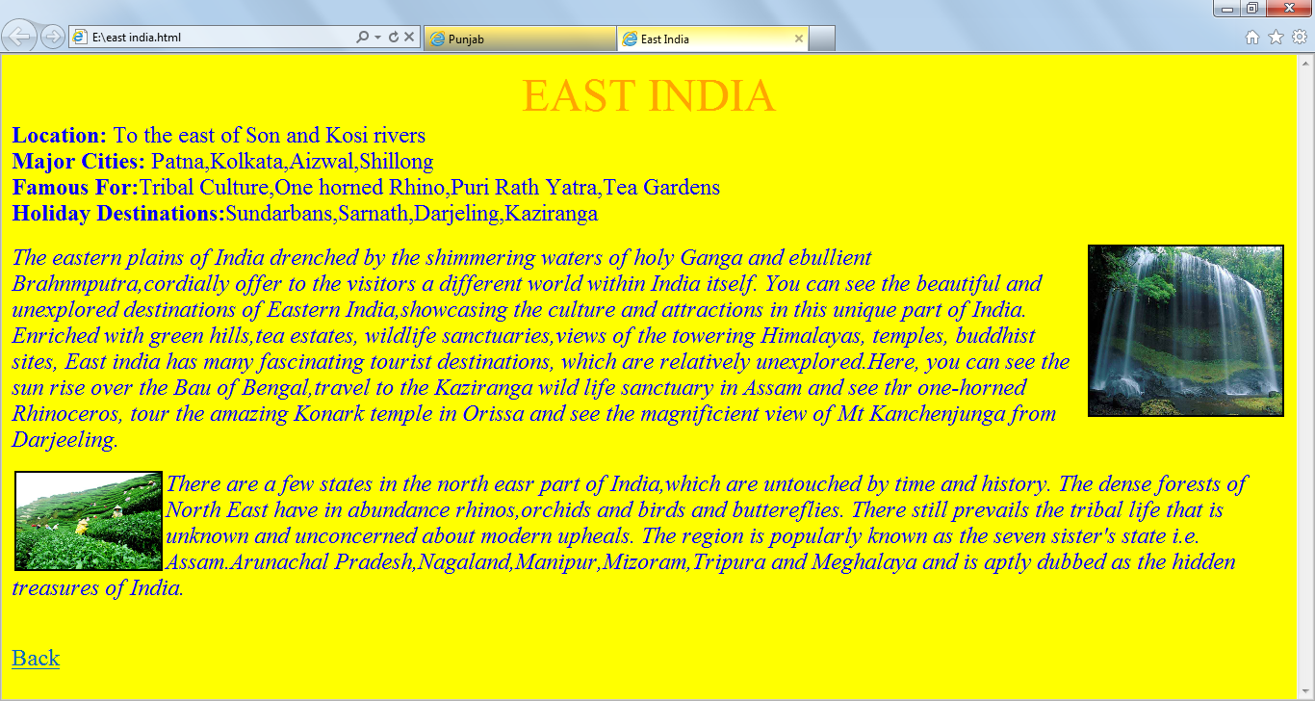

<html>

<head>

<title>

East India

</title>

</head>

<body bgcolor="yellow" text="blue">

<center>

<font color="orange" size="8">EAST INDIA</font>

</center>

<font size=5><b>Location:</b> To the east of Son and Kosi rivers<br>

<b>Major Cities:</b> Patna,Kolkata,Aizwal,Shillong<br>

<b>Famous For:</b>Tribal Culture,One horned Rhino,Puri Rath Yatra,Tea Gardens<br>

<b>Holiday Destinations:</b>Sundarbans,Sarnath,Darjeling,Kaziranga<p>

<img src="E:\east1.jpg" width= "200" height= "175" align= "right" border="2"><i>

The eastern plains of India drenched by the shimmering waters of holy Ganga and ebullient Brahnmputra,cordially offer to the

visitors a different world within India itself. You can see the beautiful and unexplored destinations of Eastern India,showcasing the

culture and attractions in this unique part of India. Enriched with green hills,tea estates, wildlife sanctuaries,views of the towering

Himalayas, temples, buddhist sites, East india has many fascinating tourist destinations, which are relatively unexplored.Here, you

can see the sun rise over the Bau of Bengal,travel to the Kaziranga wild life sanctuary in Assam and see thr one-horned Rhinoceros,

tour the amazing Konark temple in Orissa and see the magnificient view of Mt Kanchenjunga from Darjeeling.</p>

<img src="E:\east2.jpg" width="150" height="100" align="left" border="2"><p>There are a few states in the north easr part of

India,which are untouched by time and history. The dense forests of North East have in abundance rhinos,orchids and birds and

buttereflies. There still prevails the tribal life that is unknown and unconcerned about modern upheals. The region is popularly

known as the seven sister's state i.e. Assam.Arunachal Pradesh,Nagaland,Manipur,Mizoram,Tripura and Meghalaya and is aptly

dubbed as the hidden treasures of India.</p>

</i>

<br>

<a href="C:\Users\DELL\Desktop\punjab website.html">Back</a>

</font>

</body>

</html>

West India

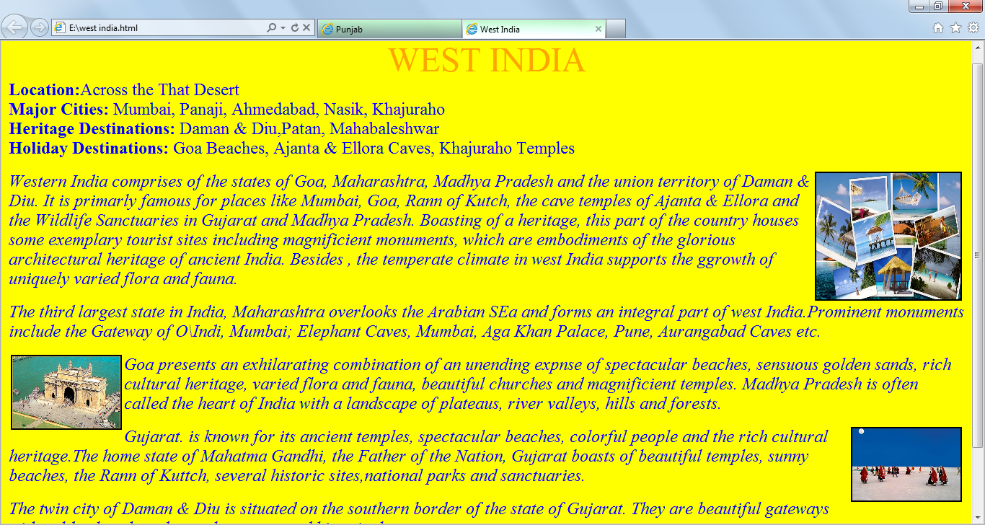

<html>

<head>

<title>

West India

</title>

</head>

<body bgcolor="yellow" text="blue">

<center>

<font color="orange" size="8">WEST INDIA</font>

</center>

<font size=5><b>Location:</b>Across the That Desert<br>

<b>Major Cities:</b> Mumbai, Panaji, Ahmedabad, Nasik, Khajuraho<br>

<b>Heritage Destinations:</b> Daman & Diu,Patan, Mahabaleshwar<br>

<b>Holiday Destinations:</b> Goa Beaches, Ajanta & Ellora Caves, Khajuraho Temples<p>

<img src="E:\west1.jpg" width= "200" height= "175" align= "right" border="2"><i>

Western India comprises of the states of Goa, Maharashtra, Madhya Pradesh and the union territory of Daman & Diu. It is primarly

famous for places like Mumbai, Goa, Rann of Kutch, the cave temples of Ajanta & Ellora and the Wildlife Sanctuaries in Gujarat and

Madhya Pradesh. Boasting of a heritage, this part of the country houses some exemplary tourist sites including magnificient

monuments, which are embodiments of the glorious architectural heritage of ancient India. Besides , the temperate climate in west

India supports the ggrowth of uniquely varied flora and fauna.</p><p>The third largest state in India, Maharashtra overlooks the

Arabian SEa and forms an integral part of west India.Prominent monuments include the Gateway of O\Indi, Mumbai; Elephant Caves,

Mumbai, Aga Khan Palace, Pune, Aurangabad Caves etc.</p>

<img src="E:\west2.jpg" width="150" height="100" align="left" border="2"><p>Goa presents an exhilarating combination of an

unending expnse of spectacular beaches, sensuous golden sands, rich cultural heritage, varied flora and fauna, beautiful churches

and magnificient temples. Madhya Pradesh is often called the heart of India with a landscape of plateaus, river valleys, hills and

forests.</p><p><img src="E:\west3.jpg" width="150" height="100" align="right" border="2">Gujarat. is known for its ancient

temples, spectacular beaches, colorful people and the rich cultural heritage.The home state of Mahatma Gandhi, the Father of the

Nation, Gujarat boasts of beautiful temples, sunny beaches, the Rann of Kuttch, several historic sites,national parks and

sanctuaries.</p><p>The twin city of Daman & Diu is situated on the southern border of the state of Gujarat. They are beautiful

gateways with golden beaches, dense plm groves and historical monuments.

</p>

</i>

<br>

<a href="C:\Users\DELL\Desktop\punjab website.html">Back</a>

</font>

</body>

</html>

South India

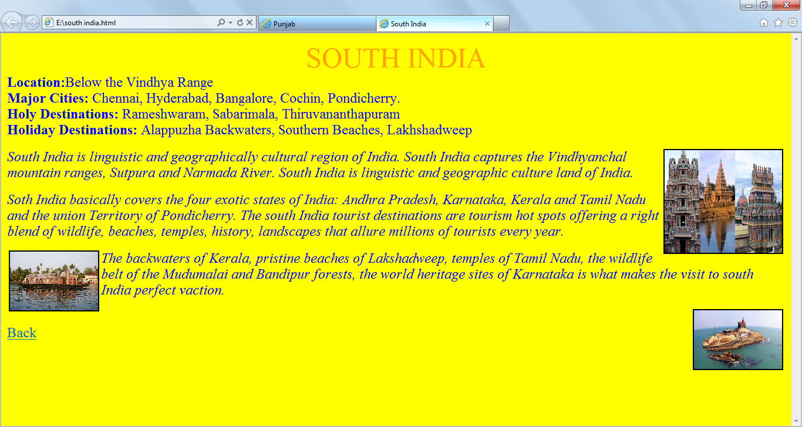

<html>

<head>

<title>

South India

</title>

</head>

<body bgcolor="yellow" text="blue">

<center>

<font color="orange" size="8">SOUTH INDIA</font>

</center>

<font size=5><b>Location:</b>Below the Vindhya Range<br>

<b>Major Cities:</b> Chennai, Hyderabad, Bangalore, Cochin, Pondicherry.<br>

<b>Holy Destinations:</b> Rameshwaram, Sabarimala, Thiruvananthapuram<br>

<b>Holiday Destinations:</b> Alappuzha Backwaters, Southern Beaches, Lakhshadweep<p>

<img src="E:\sth1.jpg" width= "200" height= "175" align= "right" border="2"><i>

South India is linguistic and geographically cultural region of India. South India captures the Vindhyanchal mountain ranges,

Sutpura and Narmada River. South India is linguistic and geographic culture land of India.</p><p>Soth India basically covers the

four exotic states of India: Andhra Pradesh, Karnataka, Kerala and Tamil Nadu and the union Territory of Pondicherry. The south

India tourist destinations are tourism hot spots offering a right blend of wildlife, beaches, temples, history, landscapes that allure

millions of tourists every year.</p>

<img src="E:\sth2.jpg" width="150" height="100" align="left" border="2"><p>The backwaters of Kerala, pristine beaches of

Lakshadweep, temples of Tamil Nadu, the wildlife belt of the Mudumalai and Bandipur forests, the world heritage sites of Karnataka

is what makes the visit to south India perfect vaction.</p><p><img src="E:\sth3.jpg" width="150" height="100" align="right"

border="2"></p>

</i>

<br>

<a href="C:\Users\DELL\Desktop\punjab website.html">Back</a>

</font>

</body>

</html>

**Travel Mart**

A Paradise Rediscovered

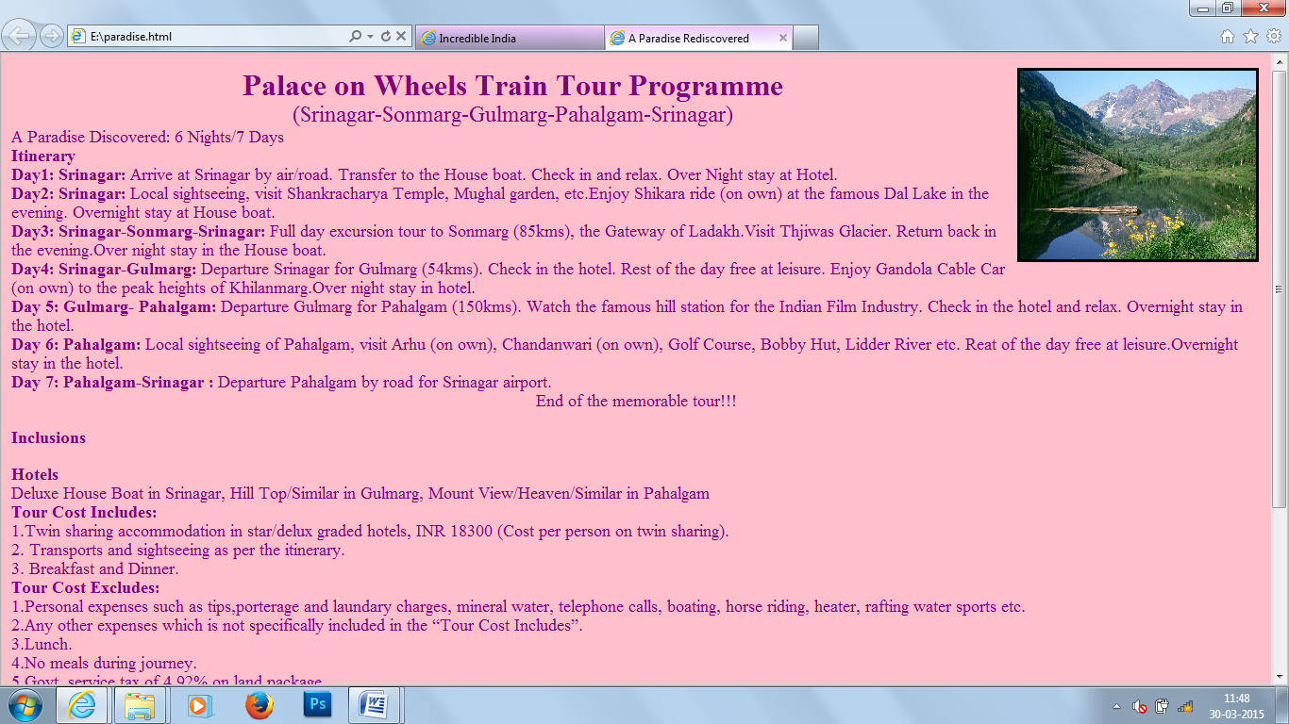

<html>

<head>

<title>

A Paradise Rediscovered

</title>

</head>

<body bgcolor="pink" text="purple">

<img src="E:\travel 7.jpg" width="250" height="200" align="right" border="3">

<font size=6><center><b>Palace on Wheels Train Tour Programme</b></center>

<font size=5><center>(Srinagar-Sonmarg-Gulmarg-Pahalgam-Srinagar)</center>

<font size=4>A Paradise Discovered: 6 Nights/7 Days

<br>

<font size=4><b>Itinerary</b></font><br>

<b>Day1: Srinagar:</b>

Arrive at Srinagar by air/road. Transfer to the House boat. Check in and relax. Over Night stay at Hotel.<br>

<b>Day2: Srinagar:</b>

Local sightseeing, visit Shankracharya Temple, Mughal garden, etc.Enjoy Shikara ride (on own) at the famous Dal Lake in the evening. Overnight stay at House boat.<br>

<b>Day3: Srinagar-Sonmarg-Srinagar:</b>

Full day excursion tour to Sonmarg (85kms), the Gateway of Ladakh.Visit Thjiwas Glacier. Return back in the evening.Over night stay in the House boat.<br>

<b>Day4: Srinagar-Gulmarg:</b>

Departure Srinagar for Gulmarg (54kms). Check in the hotel. Rest of the day free at leisure. Enjoy Gandola Cable Car (on own) to the peak heights of Khilanmarg.Over night stay in hotel.<br>

<b>Day 5: Gulmarg- Pahalgam:</b>

Departure Gulmarg for Pahalgam (150kms). Watch the famous hill station for the Indian Film Industry. Check in the hotel and relax.

Overnight stay in the hotel.<br>

<b>Day 6: Pahalgam:</b>

Local sightseeing of Pahalgam, visit Arhu (on own), Chandanwari (on own), Golf Course, Bobby Hut, Lidder River etc. Reat of the day free at leisure.Overnight stay in the hotel.<br>

<b>Day 7: Pahalgam-Srinagar :</b>

Departure Pahalgam by road for Srinagar airport.<br>

<center>End of the memorable tour!!!</center>

<h3>Inclusions</h3>

<b>Hotels</b><br>

Deluxe House Boat in Srinagar, Hill Top/Similar in Gulmarg, Mount View/Heaven/Similar in Pahalgam<br>

<b>Tour Cost Includes: </b><br>

1.Twin sharing accommodation in star/delux graded hotels, INR 18300 (Cost per person on twin sharing).<br>

2. Transports and sightseeing as per the itinerary.<br>

3. Breakfast and Dinner.<br>

<b>Tour Cost Excludes:</b><br>

1.Personal expenses such as tips,porterage and laundary charges, mineral water, telephone calls, boating, horse riding, heater, rafting water sports etc.<br>

2.Any other expenses which is not specifically included in the “Tour Cost Includes”.<br>

3.Lunch.<br>

4.No meals during journey.<br>

5.Govt. service tax of 4.92% on land package.<br><br>

<b>BOOKING TERMS AND CONDITIONS</b>

<br>

A deposit amount of 20% of the package price per person (Adult/Children) will have to be paid at time of confirmation of your booking. This said deposit amount would be adjusted towards the cost of the tour.All bookings must be made on pre-payment basis.<br>

<b>Cancellations</b><br>

If circumstances make you cancel you tour, the cancellation must be intimated to us in writing. As per this booking conditions of the tour, we are constrained to levy the following Cancellation Charges.<br>

-In case of cancellations of services,, a service fee of INR 500 will be levied per passanger.<br>

-7Days-02 Days prior to the departure of the tour-25% of the tour cost.<br>

-02Days-01 Days prior to the departure of the tour-100% of the tour cost.<br>

-In case you are a “No show” on the Tour-100% of tour cost.

</font>

</body>

</html>

Palace on Wheels

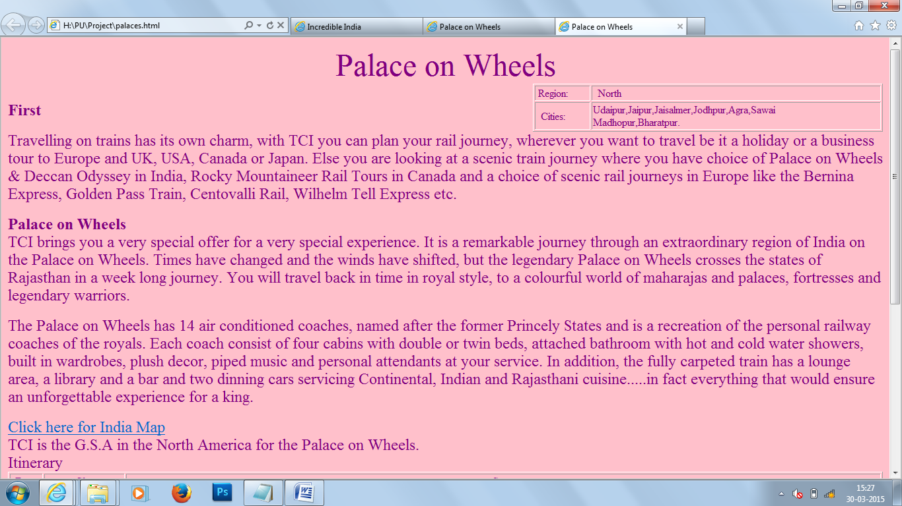

<html>

<head>

<title>

Palace on Wheels

</title>

</head>

<body bgcolor="pink">

<font size="8" color="purple"><center>Palace on Wheels</center>

<font size="5" >

<table border="1" align="right" style="width:40%">

<tr>

<td width="50"><center><font color="purple">Region:</center>

<td width="50"><center><font color="purple">North</center>

</td>

</tr>

<tr>

<td width="50"><center><font color="purple">Cities:</center>

<td width="50"><center><font color="purple">Udaipur,Jaipur,Jaisalmer,Jodhpur,Agra,Sawai Madhopur,Bharatpur.</center>

</td>

</tr>

</table>

<br>

<b>First</b>

<p>

Travelling on trains has its own charm, with TCI you can plan your rail journey, wherever you want to travel be it a holiday or a

business tour to Europe and UK, USA, Canada or Japan. Else you are looking at a scenic train journey where you have choice of

Palace on Wheels & Deccan Odyssey in India, Rocky Mountaineer Rail Tours in Canada and a choice of scenic rail journeys in

Europe like the Bernina Express, Golden Pass Train, Centovalli Rail, Wilhelm Tell Express etc.

</p>

<b>Palace on Wheels</b>

<br>

TCI brings you a very special offer for a very special experience. It is a remarkable journey through an extraordinary region of India

on the Palace on Wheels. Times have changed and the winds have shifted, but the legendary Palace on Wheels crosses the states of

Rajasthan in a week long journey. You will travel back in time in royal style, to a colourful world of maharajas and palaces, fortresses

and legendary warriors.

<p>

The Palace on Wheels has 14 air conditioned coaches, named after the former Princely States and is a recreation of the personal

railway coaches of the royals. Each coach consist of four cabins with double or twin beds, attached bathroom with hot and cold

water showers, built in wardrobes, plush decor, piped music and personal attendants at your service. In addition, the fully carpeted

train has a lounge area, a library and a bar and two dinning cars servicing Continental, Indian and Rajasthani cuisine.....in fact

everything that would ensure an unforgettable experience for a king.</p>

<a href="E:\html project\india_map.gif">

Click here for India Map</a>

<br>

TCI is the G.S.A in the North America for the Palace on Wheels.

<br>

Itinerary

<table border="1">

<tr>

<th><font color="purple">Days

<th><font color="purple">City

<th><font color="purple">Snap

<th><font color="purple">Detail

</th>

</tr>

<tr>

<td><font color="purple">1.Wed

<td><font color="purple">Delhi

<td><font color="purple">Board the Palace on Wheels at 1700hrs at Delhi Cantonment Railway Station. Depart at 1830hrs at Jaipur.

Dinner at board.

</td>

</tr>

<td><font color="purple">2.Thurs

<td><font color="purple">Jaipur

<td><font color="purple">Arrive at 0700hrs. Breakfast on Board. Welcome to the Pink City, Jaipur.

Visit Hawa Mahal and Amber Fort, both silent sentinels of a glorious era. Lunch at a palace hotel.Visit Jantar Mantar, the age old

Observatory and City Palace, home to the erstwhile rulers. Depart for Jaisalmer at 1930 hrs. Dinner on the board.

</td>

</tr>

<tr>

<td><font color="purple">3.Fri

<td><font color="purple">Jaisalmer

<td><font color="purple">Arrive at 0815hrs. Breakfast on board. Morning sightseeing of this 12th century fort. Visit the exquisitely

carved havelis and palaces with their latticed windows, balconies, cupolas and facades. Lunch on board. At 1700 hrs visit the sand

duned and take a camel ride. Dinner with Cultural programme at a palace hotel. Depart at 2345hrs for Jodhpur.

</td>

</tr>

<tr>

<td><font color="purple">4.Sat

<td><font color="purple">Jodhpur

<td><font color="purple">Arrive 0700 hrs. Breakfast on board. Visit the magnificent Mehrangarh and Jaswant Thada, the royal

cenotaph. Lunch at palace hotel. Depart for Sawai Madhopur at 1530 hrs. Dinner on board.

</td>

</tr>

<tr>

<td><font color="purple">5.Sun

<td><font color="purple">Sawai Madhopur-Chittaurgarh

<td><font color="purple">Arrive 0400 hrs. Breakfast on board. Depart by motorcoach for a Safari in Ranthambor National Park. This

Project Tiger Reserve surrounds he imposing ramparts of the 10th century fort. Depart at 1030 hrs for Chittaurgarh. Lunch on board.

Arrive at 1600 hrs. Visit the Chittaurgarh Fort, lauded in legends of valour and chivalry. Depart 2000 hrs for Udiapur. Dinner on the

board.

</td>

</tr>

<tr>

<td><font color="purple">6.Mon

<td><font color="purple">Udiapur

<td><font color="purple">Breakfast on Board. Proceed to Udaipur by motorcoach. Sightseeing of Udaipur, the city of Lakes,

Palaces, Gardens, Temples and Forts. Lunch at the Lake Palace, the former summer residence of the Princes of Mewar. Enjoy the

tranquillity of Lake Pichola. Visit the City Palace in all its ancient glory. Return to train at Chittaurgarh and depart for Agra at 1830

hrs. Dinner on board

</td>

</tr>

<tr>

<td><font color="purple">7.Tues

<td><font color="purple">Bharatpur-Agra

<td><font color="purple">Arrive at 0600 hrs at the Kepladeo Ghana National Park at Bharatpur, which is home to 300 species of

birds, some flying in from as far as Siberia and China. Breakfast on board. Depart at 1145 hrs for Fatehpur Sikri, the red sandstone

palatial complex built by Emperor Akbar which now stands deserted. Lunch on board. Depart for Agra and arrive at 1430 hrs. Visit

the Agra Fort and the beautiful Taj Mahal. Dinner on board. Depart Agra at 2300 hrs.

</td>

</tr>

<tr>

<td><font color="purple">8.Wed

<td><font color="purple">Delhi

<td><font color="purple">Arrive at 0630 hrs at Delhi Cantonment Railway Station. Breakfast on board.

<br>

<b>End of Tour</b>

</td>

</tr>

</table>

</font>

</body>

</html>

The Deccan Odyssey

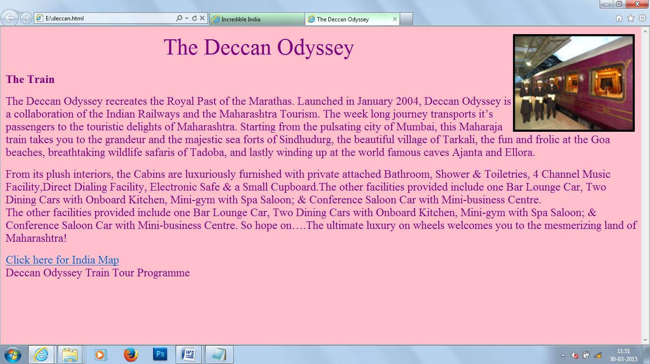

<html>

<head>

<title>

The Deccan Odyssey

</title>

</head>

<body bgcolor="pink">

<img src="E:\goldenchariot.jpg" width="250" height="200" align="right" border="3">

<font size="8" color="purple"><center>The Deccan Odyssey</center>

<font size="5" >

<br>

<b>The Train</b>

<p>

The Deccan Odyssey recreates the Royal Past of the Marathas. Launched in January 2004, Deccan Odyssey is a collaboration of the Indian Railways and the Maharashtra Tourism. The week long journey transports it’s passengers to the touristic delights of Maharashtra. Starting from the pulsating city of Mumbai, this Maharaja train takes you to the grandeur and the majestic sea forts of Sindhudurg, the beautiful village of Tarkali, the fun and frolic at the Goa beaches, breathtaking wildlife safaris of Tadoba, and lastly winding up at the world famous caves Ajanta and Ellora.

</p><p>

From its plush interiors, the Cabins are luxuriously furnished with private attached Bathroom, Shower & Toiletries, 4 Channel Music Facility,Direct Dialing Facility, Electronic Safe & a Small Cupboard.The other facilities provided include one Bar Lounge Car, Two Dining Cars with Onboard Kitchen, Mini-gym with Spa Saloon; & Conference Saloon Car with Mini-business Centre.<br>The other facilities provided include one Bar Lounge Car, Two Dining Cars with Onboard Kitchen, Mini-gym with Spa Saloon; & Conference Saloon Car with Mini-business Centre. So hope on….The ultimate luxury on wheels welcomes you to the mesmerizing land of Maharashtra!

</p>

<a href="E:\html project\india_map.gif">

Click here for India Map</a>

<br>Deccan Odyssey Train Tour Programme <br>

</font>

</body>

</html>

The Golden Chariot

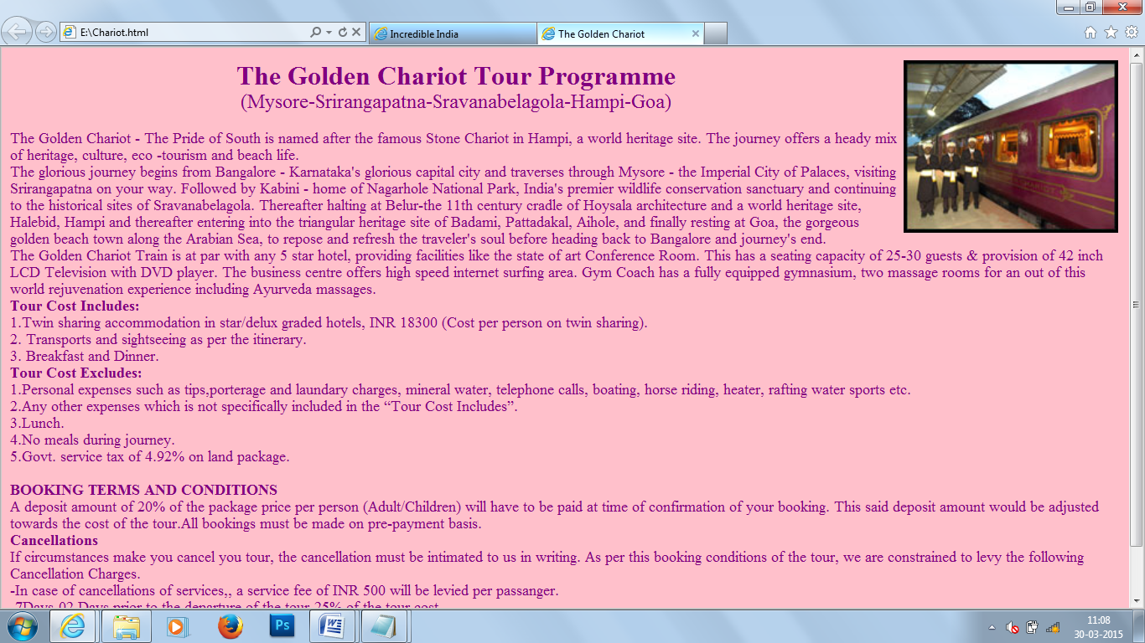

<html>

<head>

<title>

The Golden Chariot

</title>

</head>

<body bgcolor="pink" text="purple">

<img src="E:\goldenchariot.jpg" width="250" height="200" align="right" border="3">

<font size=6><center><b>The Golden Chariot Tour Programme</b></center>

<font size=5><center>(Mysore-Srirangapatna-Sravanabelagola-Hampi-Goa)</center>

<font size=4>

<br>

The Golden Chariot - The Pride of South is named after the famous Stone Chariot in Hampi, a world heritage site. The journey offers

a heady mix of heritage, culture, eco -tourism and beach life.<br>

The glorious journey begins from Bangalore - Karnataka's glorious capital city and traverses through Mysore - the Imperial City of

Palaces, visiting Srirangapatna on your way. Followed by Kabini - home of Nagarhole National Park, India's premier wildlife

conservation sanctuary and continuing to the historical sites of Sravanabelagola. Thereafter halting at Belur-the 11th century cradle

of Hoysala architecture and a world heritage site, Halebid, Hampi and thereafter entering into the triangular heritage site of Badami,

Pattadakal, Aihole, and finally resting at Goa, the gorgeous golden beach town along the Arabian Sea, to repose and refresh the

traveler's soul before heading back to Bangalore and journey's end.<br>

The Golden Chariot Train is at par with any 5 star hotel, providing facilities like the state of art Conference Room. This has a seating

capacity of 25-30 guests & provision of 42 inch LCD Television with DVD player. The business centre offers high speed internet

surfing area. Gym Coach has a fully equipped gymnasium, two massage rooms for an out of this world rejuvenation experience

including Ayurveda massages.

<br>

<b>Tour Cost Includes: </b><br>

1.Twin sharing accommodation in star/delux graded hotels, INR 18300 (Cost per person on twin sharing).<br>

2. Transports and sightseeing as per the itinerary.<br>

3. Breakfast and Dinner.<br>

<b>Tour Cost Excludes:</b><br>

1.Personal expenses such as tips,porterage and laundary charges, mineral water, telephone calls, boating, horse riding, heater,

rafting water sports etc.<br>

2.Any other expenses which is not specifically included in the “Tour Cost Includes”.<br>

3.Lunch.<br>

4.No meals during journey.<br>

5.Govt. service tax of 4.92% on land package.<br><br>

<b>BOOKING TERMS AND CONDITIONS</b>

<br>

A deposit amount of 20% of the package price per person (Adult/Children) will have to be paid at time of confirmation of your

booking. This said deposit amount would be adjusted towards the cost of the tour.All bookings must be made on pre-payment

basis.<br>

<b>Cancellations</b><br>

If circumstances make you cancel you tour, the cancellation must be intimated to us in writing. As per this booking conditions of the

tour, we are constrained to levy the following Cancellation Charges.<br>

-In case of cancellations of services,, a service fee of INR 500 will be levied per passanger.<br>

-7Days-02 Days prior to the departure of the tour-25% of the tour cost.<br>

-02Days-01 Days prior to the departure of the tour-100% of the tour cost.<br>

-In case you are a “No show” on the Tour-100% of tour cost.

</font>

</body>

</html>

**Business Industry**

IT Industry

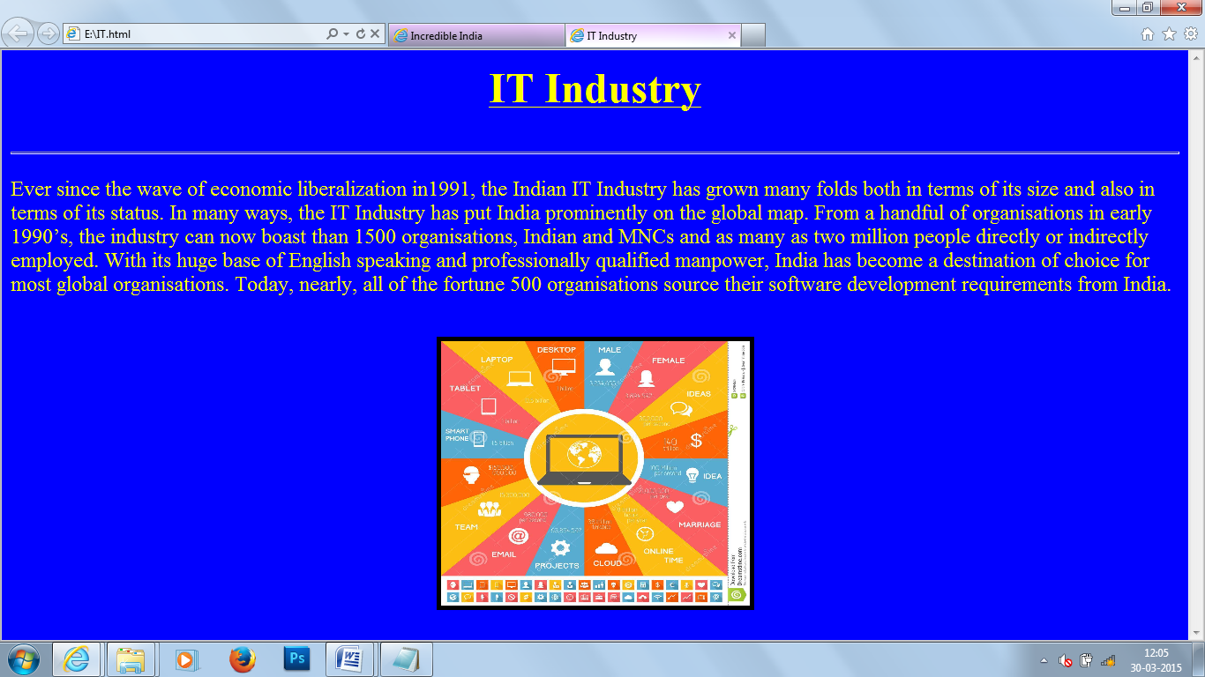

<html>

<head>

<title>

IT Industry

</title>

</head>

<body bgcolor="blue" text="yellow">

<b><u>

<center><font size=14>IT Industry</font></center>

<br><br></b></u><hr width="100%" size="3" align="center">

<p>

<font size=5>Ever since the wave of economic liberalization in1991, the Indian IT Industry has grown many folds both in terms of its size and also in terms of its status. In many ways, the IT Industry has put India prominently on the global map. From a handful of organisations in early 1990’s, the industry can now boast than 1500 organisations, Indian and MNCs and as many as two million people directly or indirectly employed. With its huge base of English speaking and professionally qualified manpower, India has become a destination of choice for most global organisations. Today, nearly, all of the fortune 500 organisations source their software development requirements from India.</p>

<br>

<center>

<img src="E:\it.jpg" width="350" height="300" border="5">

</body>

</html>

Business Process Outsourcing

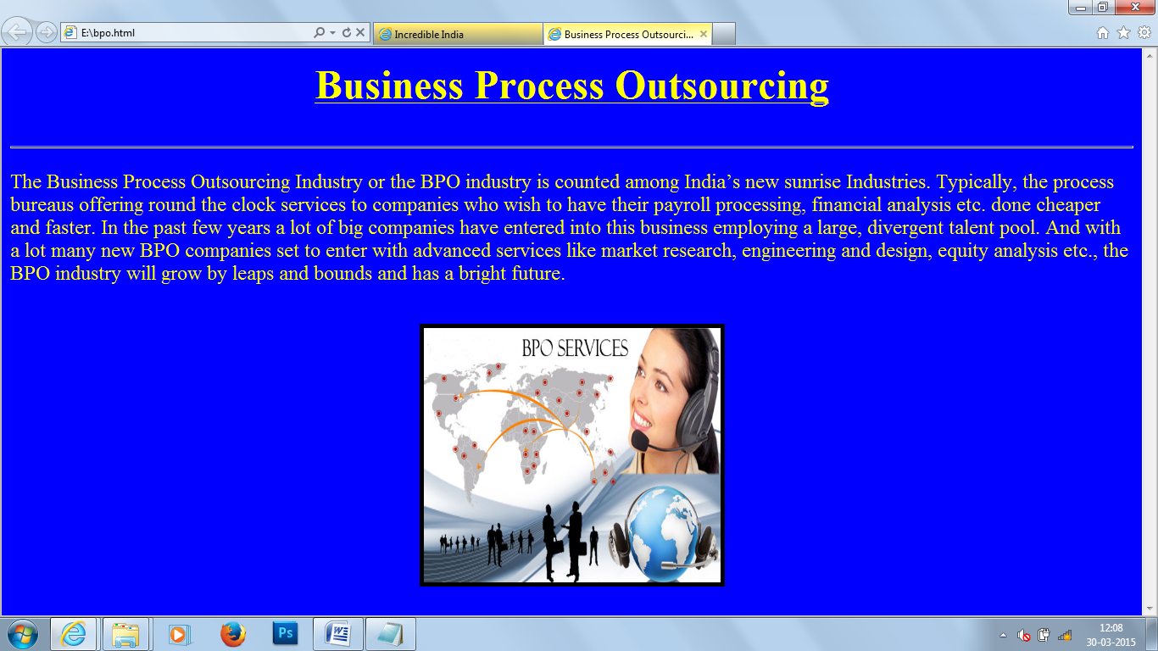

<html>

<head>

<title>

Business Process Outsourcing

</title>

</head>

<body bgcolor="blue" text="yellow">

<b><u>

<center><font size=14>Business Process Outsourcing</font></center>

<br><br></b></u><hr width="100%" size="3" align="center">

<p>

<font size=5>The Business Process Outsourcing Industry or the BPO industry is counted among India’s new sunrise Industries. Typically, the process bureaus offering round the clock services to companies who wish to have their payroll processing, financial analysis etc. done cheaper and faster. In the past few years a lot of big companies have entered into this business employing a large, divergent talent pool. And with a lot many new BPO companies set to enter with advanced services like market research, engineering and design, equity analysis etc., the BPO industry will grow by leaps and bounds and has a bright future.</p>

<br>

<center>

<img src="E:\bpo.jpg" width="350" height="300" border="5">

</body>

</html>

Media

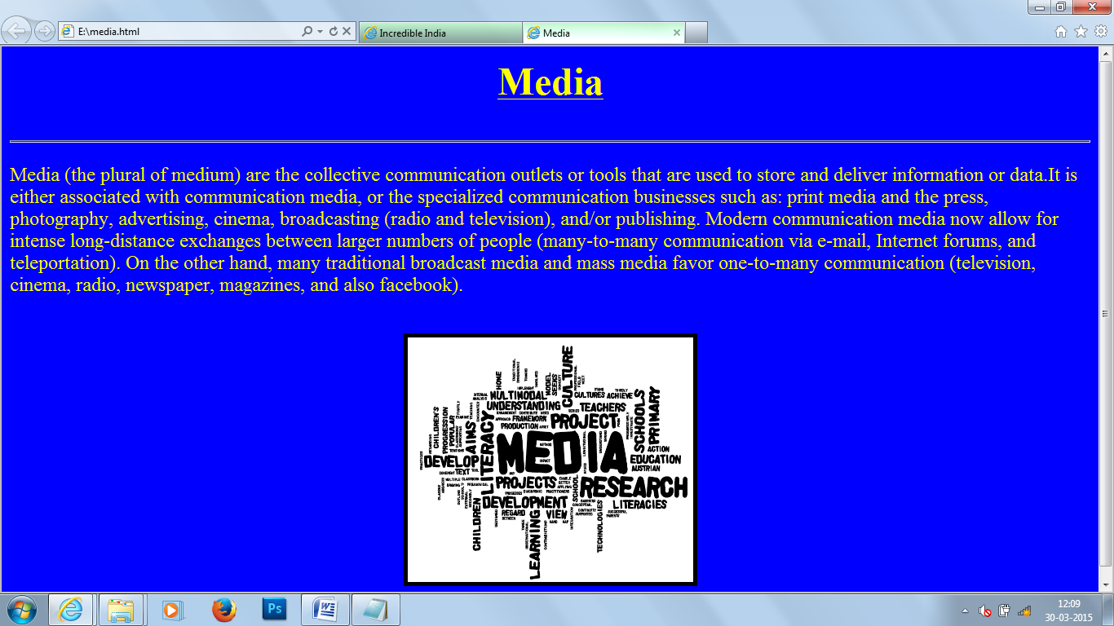

<html>

<head>

<title>

Media

</title>

</head>

<body bgcolor="blue" text="yellow">

<b><u>

<center><font size=14>Media</font></center>

<br><br></b></u><hr width="100%" size="3" align="center">

<p>

<font size=5>Media (the plural of medium) are the collective communication outlets or tools that are used to store and deliver information or data.It is either associated with communication media, or the specialized communication businesses such as: print media and the press, photography, advertising, cinema, broadcasting (radio and television), and/or publishing.

Modern communication media now allow for intense long-distance exchanges between larger numbers of people (many-to-many communication via e-mail, Internet forums, and teleportation). On the other hand, many traditional broadcast media and mass media favor one-to-many communication (television, cinema, radio, newspaper, magazines, and also facebook).</p>

<br>

<center>

<img src="E:\media.jpg" width="350" height="300" border="5">

</body>

</html>

Telecom

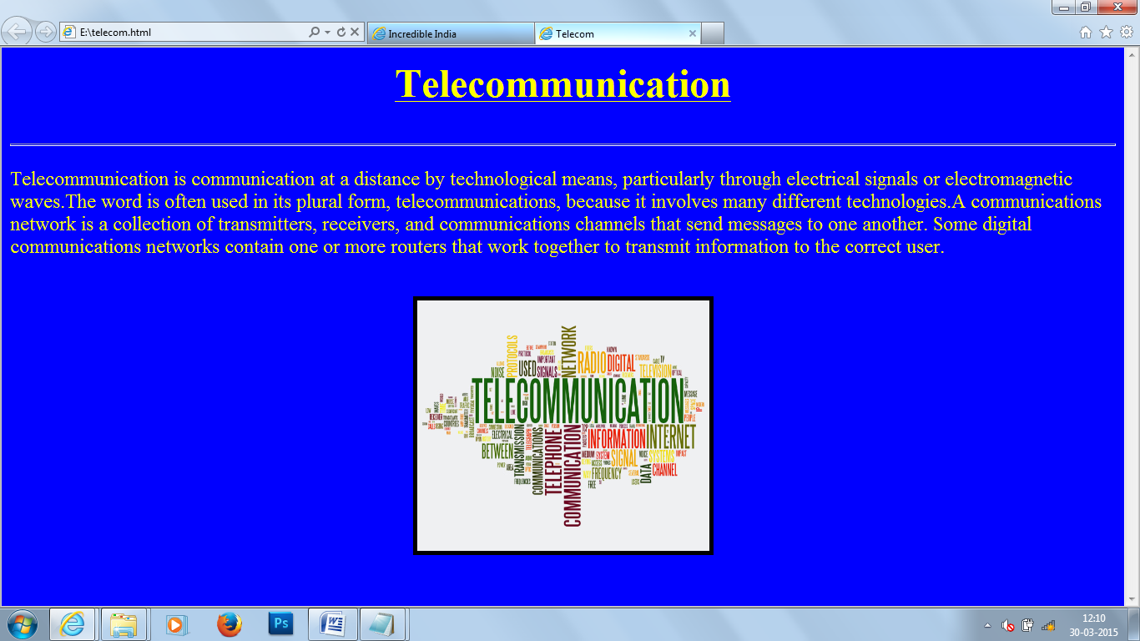

<html>

<head>

<title>

Telecom

</title>

</head>

<body bgcolor="blue" text="yellow">

<b><u>

<center><font size=14>Telecommunication</font></center>

<br><br></b></u><hr width="100%" size="3" align="center">

<p>

<font size=5>Telecommunication is communication at a distance by technological means, particularly through electrical signals or

electromagnetic waves.The word is often used in its plural form, telecommunications, because it involves many different

technologies.A communications network is a collection of transmitters, receivers, and communications channels that send

messages to one another. Some digital communications networks contain one or more routers that work together to transmit

information to the correct user. </p>

<br>

<center>

<img src="E:\telecom.jpg" width="350" height="300" border="5">

</body>

</html>

Finance

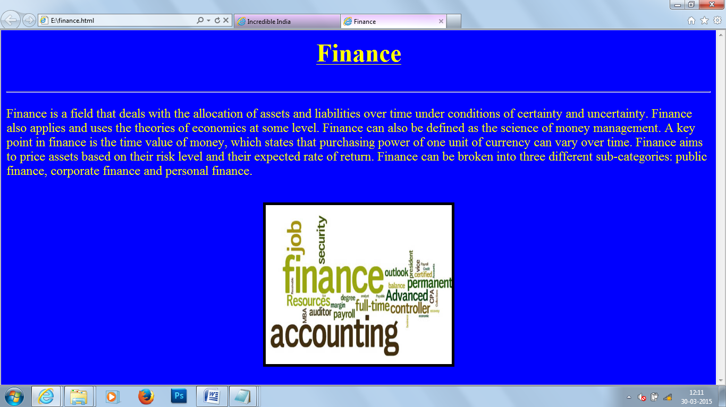

<html>

<head>

<title>

Finance

</title>

</head>

<body bgcolor="blue" text="yellow">

<b><u>

<center><font size=14>Finance</font></center>

<br><br></b></u><hr width="100%" size="3" align="center">

<p>

<font size=5>Finance is a field that deals with the allocation of assets and liabilities over time under conditions of certainty and

uncertainty. Finance also applies and uses the theories of economics at some level. Finance can also be defined as the science of

money management. A key point in finance is the time value of money, which states that purchasing power of one unit of currency

can vary over time. Finance aims to price assets based on their risk level and their expected rate of return. Finance can be broken

into three different sub-categories: public finance, corporate finance and personal finance.</p>

<br>

<center>

<img src="E:\finance.jpg" width="350" height="300" border="5">

</body>

</html>

Biotechnology

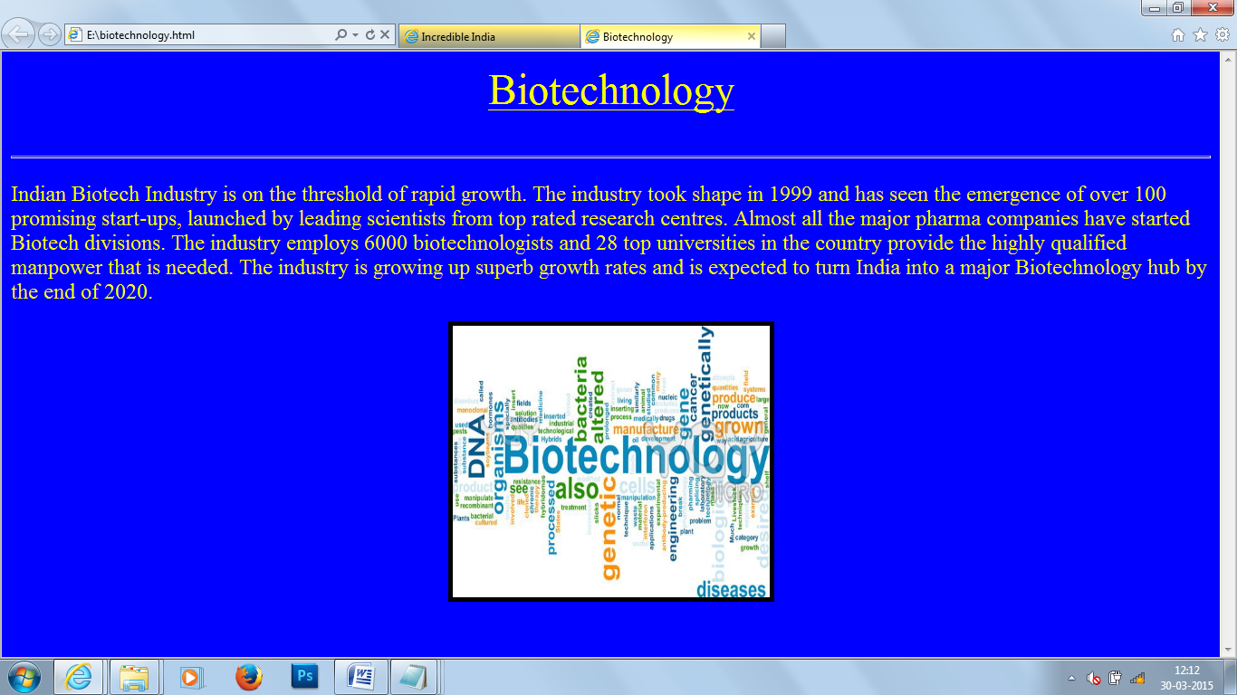

<html>

<head>

<title>

Biotechnology

</title>

</head>

<body bgcolor="blue" text="yellow">

<u>

<center><font size=14>Biotechnology</font></center></u>

<br><br></b></u><hr width="100%" size="3" align="center">

<p><font size=5>Indian Biotech Industry is on the threshold of rapid growth. The industry took shape in 1999 and has seen the

emergence of over 100 promising start-ups, launched by leading scientists from top rated research centres. Almost all the major

pharma companies have started Biotech divisions. The industry employs 6000 biotechnologists and 28 top universities in the country

provide the highly qualified manpower that is needed. The industry is growing up superb growth rates and is expected to turn India

into a major Biotechnology hub by the end of 2020.</p></font>

<center>

<img src="E:\bio.jpg" width="350" height="300" border="5">

</body>

</html>

Medical

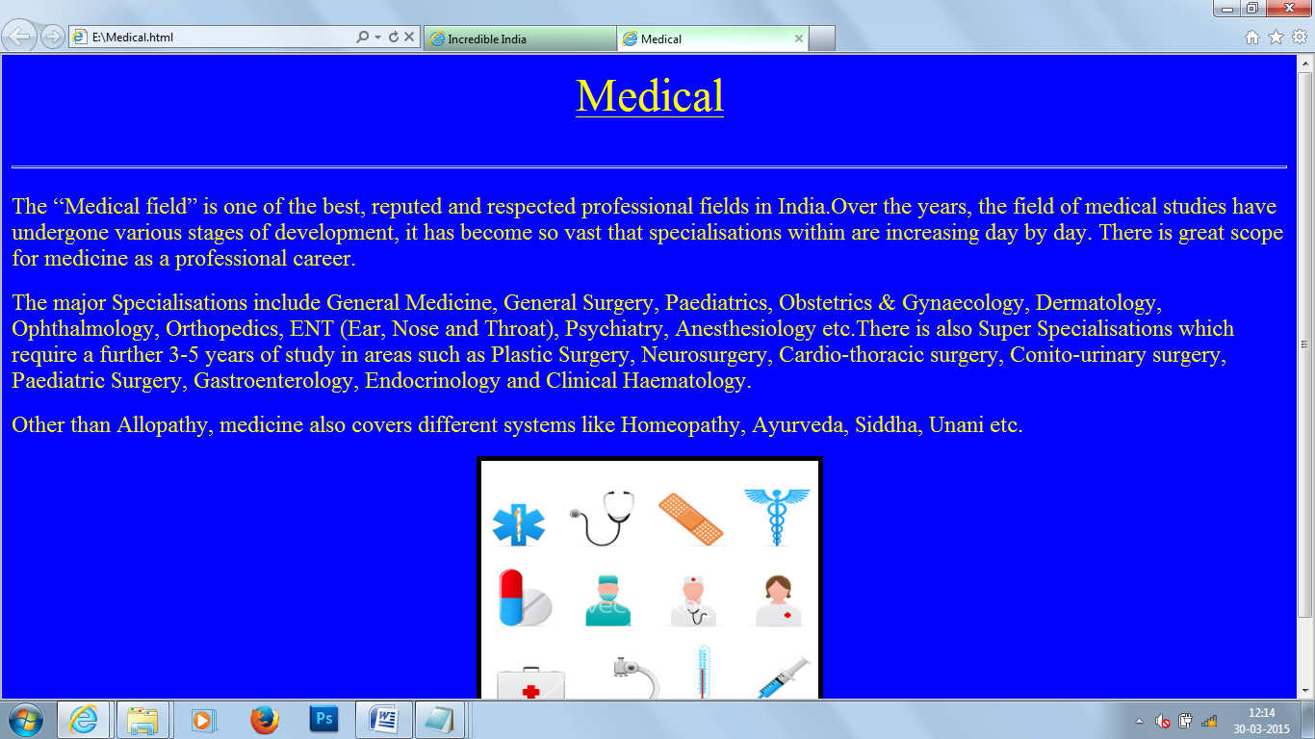

<html>

<head>

<title>

Medical

</title>

</head>

<body bgcolor="blue" text="yellow">

<u>

<center><font size=14>Medical</font></center></u>

<br><br></b></u><hr width="100%" size="3" align="center">

<p><font size=5>The “Medical field” is one of the best, reputed and respected professional fields in India.Over the years, the field of medical studies have undergone various stages of development, it has become so vast that specialisations within are increasing day by day. There is great scope for medicine as a professional career.</p><p>The major Specialisations include General Medicine, General Surgery, Paediatrics, Obstetrics & Gynaecology, Dermatology, Ophthalmology, Orthopedics, ENT (Ear, Nose and Throat), Psychiatry, Anesthesiology etc.There is also Super Specialisations which require a further 3-5 years of study in areas such as Plastic Surgery, Neurosurgery, Cardio-thoracic surgery, Conito-urinary surgery, Paediatric Surgery, Gastroenterology, Endocrinology and Clinical Haematology.</p><p>Other than Allopathy, medicine also covers different systems like Homeopathy, Ayurveda, Siddha, Unani etc.

</p></font>

<center>

<img src="E:\med.jpg" width="350" height="300" border="5">

</body>

</html>

Engineering & Architecture

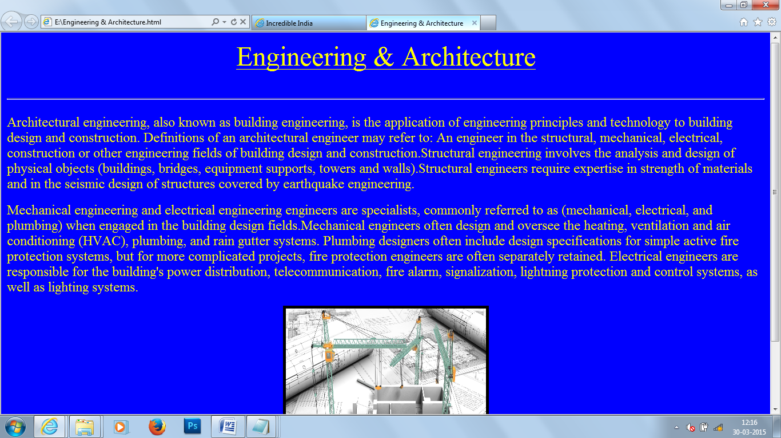

<html>

<head>

<title>

Engineering & Architecture

</title>

</head>

<body bgcolor="blue" text="yellow">

<u>

<center><font size=14>Engineering & Architecture</font></center></u>

<br><br></b></u><hr width="100%" size="3" align="center">

<p><font size=5>Architectural engineering, also known as building engineering, is the application of engineering principles and technology to building design and construction. Definitions of an architectural engineer may refer to:

An engineer in the structural, mechanical, electrical, construction or other engineering fields of building design and construction.Structural engineering involves the analysis and design of physical objects (buildings, bridges, equipment supports, towers and walls).Structural engineers require expertise in strength of materials and in the seismic design of structures covered by earthquake engineering.</p><p>Mechanical engineering and electrical engineering engineers are specialists, commonly referred to as (mechanical, electrical, and plumbing) when engaged in the building design fields.Mechanical engineers often design and oversee the heating, ventilation and air conditioning (HVAC), plumbing, and rain gutter systems. Plumbing designers often include design specifications for simple active fire protection systems, but for more complicated projects, fire protection engineers are often separately retained. Electrical engineers are responsible for the building's power distribution, telecommunication, fire alarm, signalization, lightning protection and control systems, as well as lighting systems.

</p></font>

<center>

<img src="E:\engg.jpg" width="350" height="300" border="5">

</body>

</html>